**LORAWAN Based Smart Farming Modular IOT Architecture**

**A MINI PROJECT REPORT**

*Submitted By*

|  |  |  |
| --- | --- | --- |
| **AKASH R** | **DSUG20104010** |  |
| **ARUN IYYAPPAN M** | **DSUG20104017** |  |
| **CHRISTO EDWINRAJ V** | **DSUG20104030** |  |
| **DHANUSH T** | **DSUG20104034** |  |

***in partial fulfillment for the award of the degree***

*of*

**BACHELOR OF ENGINEERING**

*in*

**COMPUTER SCIENCE AND ENGINEERING**

**DHANALAKSHMI SRINIVASAN ENGINEERING COLLEGE (AUTONOMOUS)**

**PERAMBALUR – 621 212**

**ANNA UNIVERSITY: CHENNAI 600 025**

**NOVEMBER 2023**

**LORAWAN Based Smart Farming Modular IOT Architecture**

**A MINI PROJECT REPORT**

*Submitted By*

|  |  |  |
| --- | --- | --- |
| **AKASH R** | **DSUG20104010** |  |
| **ARUN IYYAPPAN M** | **DSUG20104017** |  |
| **CHRISTO EDWINRAJ V** | **DSUG20104030** |  |
| **DHANUSH T** | **DSUG20104034** |  |

***in partial fulfillment for the award of the degree***

*of*

**BACHELOR OF ENGINEERING**

*in*

**COMPUTER SCIENCE AND ENGINEERING**

**DHANALAKSHMI SRINIVASAN ENGINEERING COLLEGE (AUTONOMOUS)**

**PERAMBALUR – 621 212**

**ANNA UNIVERSITY: CHENNAI 600 025**

**NOVEMBER 2023**

**DHANALAKSHMI SRINIVASAN ENGINEERING COLLEGE (AUTONOMOUS)**

**PERAMBALUR – 621 212**

# BONAFIDE CERTIFICATE

Certified that this project report **“LORAWAN Based Smart Farming Modular IOT Architecture”** is the bonafide work of **“AKASH R (DSUG20104010), ARUN IYYAPPAN M (DSUG20104017), CHRISTO EDWINRAJ V (DSUG20104030), DHANUSH T (DSUG20104034)”** who carried out the project work under my supervision.

**SIGNATURE**

**Dr. R. Gopi, M.Tech., Ph.D.,**

**HEAD OF THE DEPARTMENT,**

Department of Computer Science & Engineering

Dhanalakshmi Srinivasan Engineering College (Autonomous),

Perambalur – 621 212

**SIGNATURE**

**Mr. K. Aswin, M.E., SUPERVISOR,**

Department of Computer Science & Engineering

Dhanalakshmi Srinivasan

Engineering College (Autonomous),

Perambalur – 621 212

Submitted for Mini-Project Viva-Voce Examination held on________________

**INTERNAL EXAMINER EXTERNAL EXAMINER**

# ACKNOWLEDGEMENT

We express our gratitude and thanks to **Our Parents** first for giving health and a sound mind for completing this project. We give all the glory and thanks to our almighty **GOD** for showering upon, the necessary wisdom and grace for accomplishing this project.

It is our pleasant duty to express deep sense of gratitude to our honourable Chancellor **Shri. A. Srinivasan**, for his kind encouragement. We have unique pleasure in thanking our Principal **Prof. Dr. D. Shanmugasundaram, M.E., PhD., F.I.E., C.Eng.,** our Dean **Dr. K. Anbarasan**, **M.E., Ph.D.,** and our COE **Dr. K. Velmurugan, M.E., Ph.D.,** for their unflinching devotion, which leads us to complete this project.

We express our faithful and sincere gratitude to our Head of the Department **Dr. R. Gopi, M.Tech., Ph.D.,** for his valuable guidance and support that he gave us during the project time.

We express our faithful and sincere gratitude to our Mini Project Coordinator **Mrs. K. Ramya, M.E.,** of Department of Computer Science and Engineering for giving us encouragement and support throughout our project.

We are also thankful to our internal project guide **Mr. K. Aswin, M.E.,** of Department of Computer Science and Engineering for providing valuable guidance and precious suggestions to complete this project successfully.

We render our thanks to all **Faculty members** and **Programmers** of Department of

**Computer Science and Engineering** for their timely assistance.

**DHANALAKSHMI SRINIVASAN ENGINEERING COLLEGE (AUTONOMOUS)**

**DEPARTMENT OF COMPUTER SCIENCE AND ENGINEERING**

**Vision and Mission of the Department:**

**Vision**

To produce globally competent, socially responsible professionals in the field of Computer Science and Engineering.

**Mission**

**M1:** Impart high quality experiential learning to get expertise in modern software tools

**M2:** Inculcate industry exposure and build inter disciplinary research skills.

**M3:** Mould the students to become Software Professionals, Researchers and Entrepreneurs by providing advanced laboratories.

**M4:** Acquire Innovative skills and promote lifelong learning with a sense of societal and ethical responsibilities

**Program Educational Objectives (PEOs)**

**PEO 1:** Graduates of the programme will develop proficiency in identifying, formulating, and resolving complex computing problems.

**PEO 2:** Graduates of the programme will achieve successful careers in the field of computer science and engineering, pursue advanced degrees, or demonstrate entrepreneurial success.

**PEO 3:** Graduates of the programme will cultivate effective communication skills, teamwork abilities, ethical values, and leadership qualities for professional engagement in industry and research organizations.

**ABSTRACT**

Contemporary the Internet of Things (IoT) is one of the highest promising application areas in information technology for forthcoming products and services. And the agriculture field is changing expeditiously pointing to the future of automated and embedded systems with a bunch of sensors to monitor and curb the flourishing plants in a way to profit associated with it. The persistent monitoring and controlling of distantly located plants is labor compact and technically tough business. In modern agriculture, a Wireless Sensor Network (WSN) provides a simple cost-effective solution to monitor and control. However, one of the major issues of IoT is still a conversation between devices, notably on long-range. It implies that LoRa is lately accepted as auspicious communication technology, due to its properties such as long-range, two-way communication, and with low cost. It is stated that the communication distance of LoRa is up to 10 km, but it is not clear in what measure does. The communication distance is affected by the environmental conditions, parameters of devices, etc. Here we merge the LoRa WSN technology in the agriculture sector for making long-distance, low-cost communication. This report presents a comprehensive study on leveraging LoRaWAN technology for collecting agricultural data from end nodes, transmitting it to a cloud platform through gateways. A web-based visualization tool for the collected data is also presented, to validate the LoRaFarM architecture.

# TABLE OF CONTENTS

|  |  |  |
| --- | --- | --- |
| **CHAPTER NO** | **TITLE** | **PAGE NO** |
|  | **ABSTRACT** | V |
|  | **LIST OF TABLES** | ix |
|  | **LIST OF FIGURES** | X |
|  | **LIST OF ABBREVIATIONS** | xii |
| **1** | **INTRODUCTION**   * 1. OBJECTIVE | 1  2 |
| **2** | **LITERATURE SURVEY**   1. Development Of WSN System for Precision Agriculture 2. Internet Of Things (Iot) For Precision Agriculture Application 3. Iot Based Intelligent Agriculture Field Monitoring System 4. Iot Based Smart Agriculture System 5. Iot Based Smart Crop-Field Monitoring and Automation Irrigation System | 3  3  4  5  6  7 |
| **3** | **SYSTEM ANALYSIS**   * 1. EXISTING SYSTEM      1. Disadvantages   2. PROPOSED SYSTEM      1. Advantages | 8  8  8  9  10 |
| **4** | **SYSTEM REQUIRMENTS**   * 1. HARDWARE REQUIRMENTS   2. SOFTWARE REQUIRMENTS | 11  11  11 |
| **5** | **SOFTWARE DESCRIPTION**   * 1. LORA WIRELESS TECHNOLOGY   2. PHP   3. XAMPP   4. ARDUINO IDE   5. VISUAL STUDIO CODE | 12  12  13  14  15  15 |
| **6** | **SYSTEM DESIGN**   * 1. SYSTEM ARCHITECTURE   2. LORAWAN GATEWAY   3. LORAWAN ENDNODE   4. COMPONENTS REQUIRED | 16  16  17  18  19 |
| **7** | **SYSTEM IMPLEMENTATION**   * 1. MODULE SPECIFICATION   2. MODULE DESCRIPTION      1. Installing The ESP32 and Lora Library in Arduino IDE      2. Implementation Of the ESP32 Lorawan Gateway      3. Implementation Of the ESP32 Sensor Node      4. Prepare Database and Webpage      5. 000Webhost Web Hosting | 32  32  32  32  33  35  38  39 |
| **8** | **SYSTEM TESTING**   * 1. TYPES OF TESTING      1. Unit Testing      2. Integration Testing      3. Functional Test      4. System Test      5. White Box Testing      6. Black Box Testing   2. UNIT TESTING      1. Test Strategy and Approach      2. Test Objectives      3. Features To Be Tested   3. INTEGRATION TESTING   4. ACCEPTANCE TESTING | 42  42  42  42  42  43  43  43  43  43  44  44  44  44 |
| **9** | **CONCLUSION AND FUTURE ENHANCEMENT**   * 1. CONCLUSION   2. FUTURE ENHANCEMENT | 45  45  45 |
| **10** | **APPENDICES**  APPENDIX I SOURCE CODE  APPENDIX II SCREENSHOTS  **REFERENCES** | 46  46  55  58 |

## LIST OF TABLES

|  |  |  |
| --- | --- | --- |
| **TABLE NO** | **TITLE** | **PAGE NO** |
| 6.1 | Components used in this project | 19 |
| 6.2 | Specifications OF ESP32 DEVKIT V1 DOIT | 20 |
| 6.3 | Pin Configuration of DHT11 | 24 |
| 6.4 | Pin Configuration of Soil moisture Sensor | 26 |
| 6.5 | Pin Configuration detail of I2c Module | 27 |
| 6.6 | Pin Configuration of Relay | 29 |
| 6.7 | Pin Configuration of Raindrop sensor | 31 |
| 7.1 | ESP32 to LoRa Interaction Tx | 34 |
| 7.2 | ESP32 to LoRa Interaction Rx | 35 |
| 7.3 | ESP32 with Sensor interaction | 37 |

## LIST OF FIGURES

|  |  |  |
| --- | --- | --- |
| **FIG.NO** | **FIGURE NAME** | **PAGE NO** |
| 1.1 | WSN Comparison Graph | 2 |
| 3.1 | Existing workflow | 8 |
| 3.2 | Implemented workflow | 9 |
| 5.1 | Communication protocol and system architecture of LoRaWAN | 12 |
| 5.2 | LoRa Communication stack | 13 |
| 5.3 | XAMPP interface | 14 |
| 5.4 | Arduino IDE | 15 |
| 6.1 | LoRaWAN architecture | 17 |
| 6.2 | LoRaWAN Gateway | 18 |
| 6.3 | LoRaWAN End Node | 19 |
| 6.4 | DOIT ESP32 DEVKIT V1 BOARD | 20 |
| 6.5 | LoRa SX1278 RA02 | 21 |
| 6.6 | LoRa Antenna | 21 |
| 6.7 | LDR Sensor (Light Dependent Resistor) | 22 |
| 6.8 | LDR sensor sense Some amount of Light | 22 |
| 6.9 | LDR sensor sense no Light | 23 |
| 6.10 | Temperature and Humidity Sensor | 23 |
| 6.11 | Soil Moisture Sensor | 25 |
| 6.12 | Liquid Crystal Display (16x2) | 26 |
| 6.13 | I2c Module | 27 |
| 6.14 | Double Channel Relay | 28 |
| 6.15 | Submersible Water Pump | 30 |
| 6.16 | Buzzer | 30 |
| 6.17 | Raindrop Sensor | 31 |
| 6.18 | Breadboard 840 points | 31 |
| 7.1 | LoRa with ESP32 Transmitter | 33 |
| 7.2 | Block Diagram of Receiver with Gateway | 34 |
| 7.3 | Block Diagram of Transmitter with Sensors | 37 |
| 7.4 | XAMPP Control Panel | 38 |
| 7.5 | phpMyAdmin Database | 39 |
| 7.6 | Login Page of 000webhost | 39 |
| 7.7 | Dashboard of 000webhost | 40 |
| 7.8 | File manager of 000webhost | 40 |
| 7.9 | Database Manager of 000webhost | 41 |
| 10.1 | Implemented Receiver with Gateway | 55 |
| 10.2 | Implemented Transmitter with Sensors | 55 |
| 10.3 | Sensor Node TX RX With Serial Monitoring | 56 |
| 10.4 | Smart Agriculture Home Page of Web Site | 56 |
| 10.5 | Collection of Live Sensor data in Table Form on Web Site | 57 |

## LIST OF ABBREVIATIONS

|  |  |  |
| --- | --- | --- |
| **WSN** | - | **W**ireless **S**ensor **N**etwork |
| **LoRa** | - | **L**ong **R**ange |
| **BLE** | - | **B**luetooth **L**ow **E**nergy |
| **IOT** | - | **I**nternet **O**f **T**hings |
| **RF** | - | **R**adio **F**requency |
| **Tx** | - | **T**ransmitter |
| **Rx** | - | **R**eceiver |

**CHAPTER 1**

**INTRODUCTION**

In our modern world, many people are making full use of technology, and because of that, they are doing their job soon and well. But still, many rural farmers cannot use technology more. Also, the demand for food supply is increasing due to an increase in the global population. At that time, IoT(Internet of Things) tends to develop certain techniques in the field of agriculture to increase food production. The farmers can also get useful information regarding the moisture and soil requirements etc. So we are implementing this smart agricultural system for them.

With the help of this system, farmers can examine the temperature, humidity & soil moisture of their farm, which is done by various IOT sensors like DHT, Soil moisture, as well as control various components, like motor, etc. This system is very easy and simple to use, it works wholly on wireless technology. To use this system the farmer has to place the transmitter module in different places in his field and the receiver is put in his home and connected to the server. Now, the farmer can monitor and control the system by the website or mobile application.

As discussed earlier, this system is formed by using wireless technology and we already have a handful of wireless protocols like BLE (Bluetooth Low Energy), Wi-Fi, and cellular, etc. But these technologies are not ideal for IoT sensor nodes, because they needed to transmit information to a long distance without using much power and with low cost. Apart from this LoRa technology plays a vital role in the agriculture sector.

That’s why we are using LoRa technology, which can perform very-long range transmission of data or information at low cost and without an internet connection.

The term LoRa stands for Long Range. It is a wireless radio frequency technology introduced by Sem tech. LoRa is used to transmitting information in both directions to long-distance and typically LoRa can achieve a distance of 15 to 20 km and can work on battery for a year.

In wireless technology solution, BLE works with low power, but cannot send data to long distance. While using LoRa we can achieve high distance communication without an internet connection, thus it overcomes the drawbacks of Wi-Fi and BLE communication.

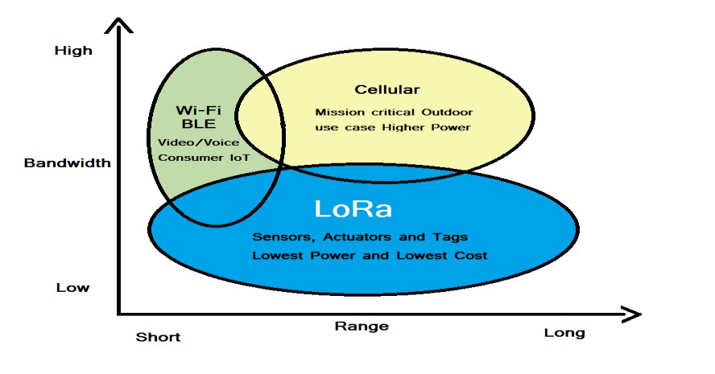The below chart provides a difference between WSN technology.

**Figure 1.1: WSN Comparison Graph**

## OBJECTIVE

The objective of a smart agricultural system using LoRa wireless technology is to observe and control the temperature, humidity, moisture, and motor of the field via website and android mobile application. Field data will transmit using LoRa technology, without an internet connection, and with high distance.

**CHAPTER 2**

**LITERATURE SURVEY**

* 1. **Title: Development of WSN System for Precision Agriculture**

# Author Name: Santoshkumar, Udaykumar R.Y

# Year: 2015

Santoshkumar in their research, select various sensors and methods for precision agriculture such as temperature sensor, humidity sensor, and Arduino (ATMega328) microcontroller board with the wireless sensor network system. The role of WSN is to sense the remote data from the desired location and transmit through the wireless network which can be viewed by the receiver. The earlier monitoring systems had a lot of limitations such as distance and reliability factors. Previously, the wireless networks used RF technology which was replaced by Bluetooth technology, and Bluetooth has replaced by ZIGBEE technology. Santoshkumar, discusses the development of the WSN system for precision agriculture based on the Zigbee wireless sensor network. The ZIGBEE is used as LR-WPAN i.e. low rate wireless personal area network. According to them, using ZIGBEE devices in a WPAN can communicate at speeds up to 250 Kbps while physically separated by distances up to 50 meters in typical circumstances and greater distances in an ideal environment.

## ADVANTAGES:

* WSN provides a simple cost effective solution to monitor and control. ZIGBEE technology is used as WSN.

## DISADVANTAGES:

* Use of different languages can encompass further usage of the model at hand.
  1. **Title: Internet of Things (IoT) for Precision Agriculture Application**

# Author Name: Manishkumar Dholu, Mrs. K. A. Ghodinde

# Year: 2018

M. Dholu, proposed and designed an IoT for precision agriculture application. This proposed system consists of various components like humidity & temperature sensor, soil moisture sensor, and a microcontroller unit (MCU) along with the Wi-Fi module, using the Wi-Fi router uploaded the sensed data on Thingspeak cloud and finally displayed it on the mobile application. According to them, soil moisture measurement has done by using the YL – 69 electrodes. There is two terminal in electrode between which the resistance is measured. With a change in the soil moisture the resistance between these two-point changes. So this change in moisture is the measure of the amount of moisture in the soil. YL–38 is a chip which is used in the proposed work to convert the change in resistance into an analog voltage, it is fed with 3.3 v supply so it gives an output from 0 to 3.3 v.

## ADVANTAGES:

* Communication with the gateway wirelessly through WiFi module as it gives an advantage over Bluetooth.

## DISADVANTAGES:

* Wi-Fi has short-range communication, over LoRa WSN.
  1. **Title: IoT Based Intelligent Agriculture Field Monitoring System**

# Author Name: Md Ashifuddin Mondal, Zeenat Rehena

# Year: 2018

# 

Md Ashifuddin Mondal and Zeenat Rehena on IoT Based Intelligent Agriculture Field Monitoring Systems, the authors delve into the technological landscape of agricultural monitoring, focusing on the integration of Internet of Things (IoT) technologies. By examining existing literature, the authors shed light on the challenges and advancements in this field, providing valuable insights into the technical complexities associated with IoT implementation in agriculture. Through their meticulous review, Mondal and Rehena contribute to the existing knowledge base, offering researchers and practitioners a nuanced understanding of the state-of-the-art technologies and the hurdles that need to be overcome for the successful deployment of IoT-based Intelligent Agriculture Field Monitoring Systems.

## ADVANTAGES:

* The level of water content is low the pump gets ON automatically or the level of water content in land is high the pump gets OFF automatically.

## DISADVANTAGES:

* Many IoT devices used in agriculture, such as sensors and actuators, rely on batteries. These batteries have a limited lifespan, and replacing them can be costly and time-consuming, especially if the devices are deployed in remote locations.
  1. **Title: IOT Based Smart Agriculture System**

# Author Name: G. Sushanth, S. Sujatha

# Year: 2020

G. Sushanth and S. Sujatha offer a detailed exploration of the advancements in agricultural technologies driven by the integration of Internet of Things (IoT). Their research delves into various aspects of smart agriculture, including precision farming, crop monitoring, and automated irrigation systems. Through a systematic review of existing literature, the authors analyze the implementation of IoT devices, data analytics, and wireless communication protocols in the context of agriculture. By critically evaluating the methodologies and outcomes of previous studies, Sushanth and Sujatha provide valuable insights into the evolving landscape of smart agriculture, emphasizing the potential benefits in terms of resource efficiency, crop yield optimization, and sustainable farming practices. Their work not only consolidates the existing knowledge in the field but also highlights key areas for future research and development, making it a significant contribution to the domain of IoT-based agricultural systems.

## ADVANTAGES:

* Send suggestions via SMS to the farmer directly on his mobile using the GSM module instead of the mobile app.

## DISADVANTAGES:

* Android mobile and, continuous internet connectivity is required.
  1. **Title: Iot Based Smart Crop-Field Monitoring And Automation**

**Irrigation System**

# Author Name: R. Nageswara Rao, B. Sridhar

# Year: 2018

# 

R. Nageswara Rao and B. Sridhar delve into the realm of precision agriculture by examining the integration of Internet of Things (IoT) technologies in crop-field monitoring and irrigation systems. Their comprehensive review explores the diverse array of sensors, data analytics techniques, and automation technologies employed in modern agriculture. By synthesizing information from various studies, Rao and Sridhar provide valuable insights into the potential of IoT-based smart systems in optimizing crop yields, conserving water resources, and promoting sustainable farming methods. Their literature survey serves as a valuable resource for researchers, practitioners, and policymakers, offering a deep understanding of the evolving landscape of smart crop-field monitoring and automation irrigation systems, while also highlighting key challenges and opportunities in this field.

## ADVANTAGES:

* The main Advantage of this work is crop development at low quantity water consumption.

## DISADVANTAGES:

* Raspberry PI is Expensive, and This should be properly shutdown otherwise there is a risk of file corruption and software problems.

**CHAPTER 3**

**SYSTEM ANALYSIS**

# 3.1 EXISTING SYSTEM

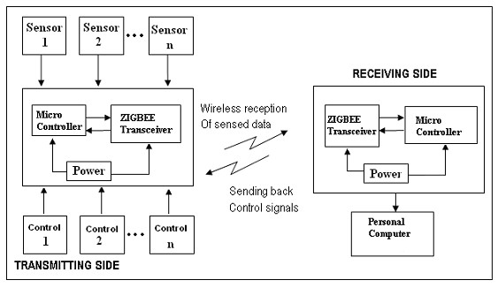Santoshkumar, have discussed the development of the WSN system for precision agriculture based on the ZIGBEE wireless sensor network.

**Figure 3.1: Existing workflow**

Santoshkumar and Udaykumar R.Y have proposed the WSN node using ZIGBEE. In this model, at the transmitting side, the Microcontroller and ZIGBEE transceiver is power by the external power supply and different sensors are connected with a microcontroller. All the sensor’s data are controlled and collected by the microcontroller, and using the ZIGBEE transceiver transmits the sensed data wirelessly. At the receiving side, another microcontroller and the ZIGBEE transceiver are there, it will receive the sensed data and use for the personal computer. They have used WSN as a ZIGBEE, operating at 868 MHz, 902-928 MHz, and 2.4 GHz, and communicate at speeds up to 250kbps while physically separated by distances up to 50 meters.

## 3.1.1 DISADVANTAGES

* IoT devices in agriculture often require long battery life, especially in remote areas where frequent battery replacements are challenging. Cellular networks, with their high-speed data capabilities, tend to consume significant power, making them unsuitable for long-term deployment in agricultural IoT devices.
* Agricultural fields are often located in remote or rural areas where cellular network coverage may be limited. This lack of coverage hampers the connectivity of IoT devices, making it difficult to collect real-time data from these regions.
* Traditional methods are limited in their ability to provide highly accurate and localized weather forecasts, leading to uncertainties in agricultural planning.

# 

# PROPOSED SYSTEM

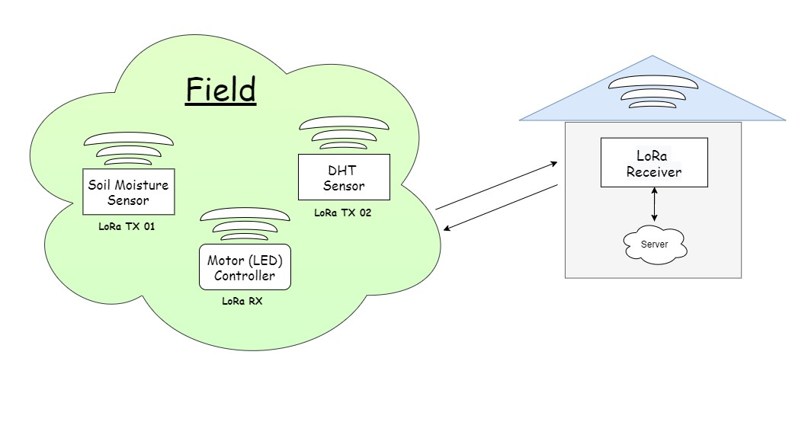One wireless network is formed with the help of LoRa technology which contains a transmitter and receiver. We have divided this technology into two parts, one for field and another for the control hub (farmer’s home). Talking about the field area, One transceiver has a moisture sensor, another has a DHT sensor. Both the transmitter generates useful data of farm like the data of temperature and humidity which is generated by the DHT sensor, and the data of available moisture in the soil, generated by a soil moisture sensor. Now moving towards the control hub which contains a transceiver connected to the operating device. The role of the transceiver is to receive the whole data generated by the onfield components and also transmit the command to control the motor whereas the device stores the data and displays on the website and mobile application for remotely monitoring.

**Figure 3.2 Implemented workflow**

## 3.2.1 ADVANTAGES

* Farmers can remotely monitor and control IoT devices through the web interface, providing convenience and flexibility in agricultural management.
* LoRaWAN technology enables long-range communication between sensors and gateways, covering vast agricultural areas. This extensive coverage ensures that data can be collected from sensors spread across large farms, even in remote or rural areas with limited infrastructure.
* LoRaWAN devices are designed to operate on low power, leading to extended battery life for sensors. This low power consumption is crucial for agricultural applications, where devices often need to operate for long durations without frequent battery replacements, reducing maintenance efforts and costs.
* LoRaWAN networks have lower operating costs compared to cellular networks. This cost-effectiveness makes it viable for farmers, especially small-scale and resource-limited ones, to implement IoT solutions without a substantial financial burden.
* LoRaWAN-enabled sensors can monitor environmental conditions such as weather patterns, helping farmers anticipate adverse weather events, optimize planting and harvesting schedules, and mitigate potential crop damage, thereby enhancing overall farm productivity.

**CHAPTER 4**

**SYSTEM REQUIRMENTS**

* 1. **HARDWARE REQUIRMENTS**
* CPU type: Intel Pentium 4
* Clock speed: 3.0 GHz
* Ram size: 2 GB
* Hard disk capacity: 40 GB
* Monitor type: 15 Inch color monitor
* Keyboard type: internet keyboard
  1. **SOFTWARE REQUIRMENTS**
* Operating System: Windows OS
* Language: HTML, CSS, AJAX, JAVASCRIPT, PHP
* Back End: MYSQL Server, PHP
* IDE: Visual Studio Code, Arduino IDE, XAMPP
* Application: Windows Application

**CHAPTER 5**

**SOFTWARE DESCRIPTION**

* 1. **LoRa WIRELESS TECHNOLOGY**

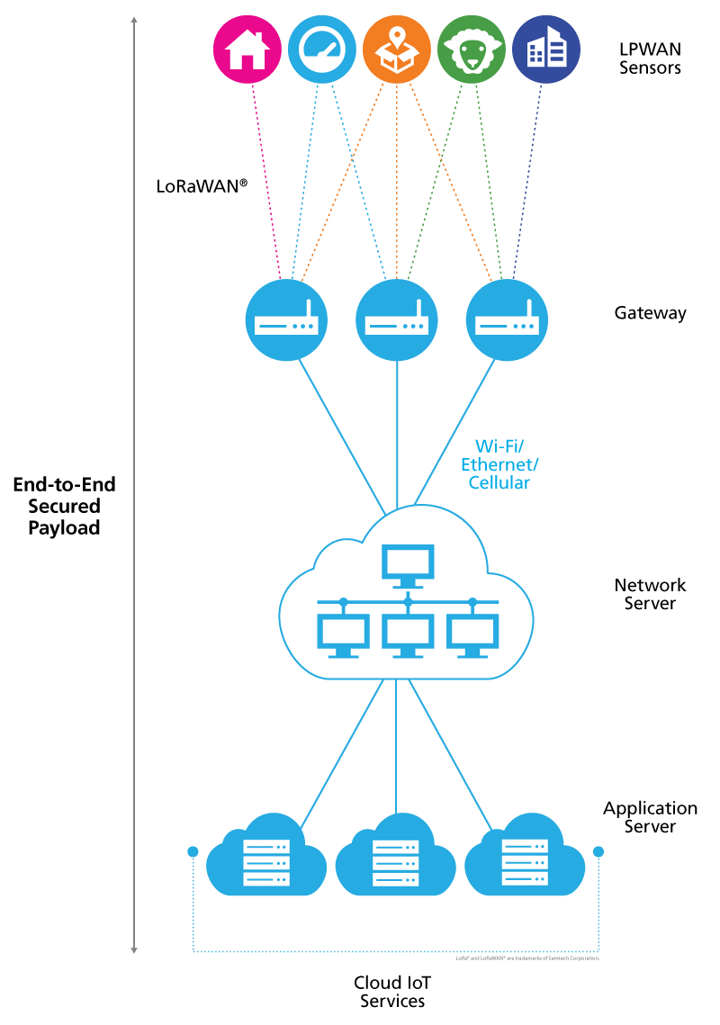In this section, the basic concepts of LoRaWAN, LPWAN, and LoRa technologies will be described. Figure 5.1, characterizes typical parts and architecture of an LPWAN network. The LPWAN sensors, or an end node, collect different measured values and using LoRaWAN to send the data to the gateway. The gateway transmits the data to some internet cloud service. The client can use that collected data from cloud services. The advantage of LoRa lies in technology’s long-range capability. A single base station can cover hundreds of square kilometers, but the range is highly dependent on the environment or obstructions. The LoRa modulation can be utilized by many different protocol architectures such as Star, and Mesh.

**Figure 5.1: Communication protocol and system architecture of LoRaWAN**

LoRaWAN ensures data rates from 0.3 kbps up to 50 kbps, which are considered acceptable for transmitting real-time sensor data in the IoT. The bandwidth of LoRa is low, nonetheless, transmitting anything that requires high bandwidth, or transmission of real-time image data, that may not suitable on the LoRa network.

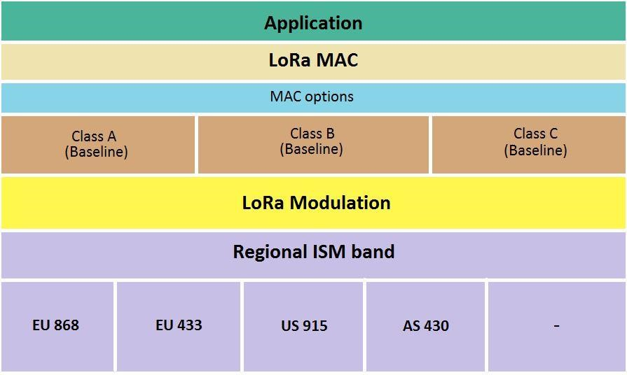LoRaWAN defines three classes of devices. These device classes can negotiate network downlink communication latency versus the battery lifetime. These classes are shown in Fig. 3.9 and, depending on the application needs, A, B, or C class can be chosen. Battery-powered devices in “Class A” are intended for low powered devices such as sensors, these are the most energy-efficient class but have the biggest latency time. It also includes devices that do not need to transmit data all the time. All the LoRaWAN-capable devices must support the functionalities of this class. Class B is focused on battery-powered devices such as sensors. These are energy efficient but with a latency controlled downlink. And the C class is used by bi-directional (both direction) with maximal receive slots, which has almost continuously open receive windows, which are only closed when transmitting.

**Figure 5.2: LoRa Communication stack**

LoRaWAN network protocol security is based on IEEE 802.15.4 and is also extended by using two session keys: a network session key and an application session key. Each LoRaWAN edge node device also has its own 128-bit AES key, known as the AppKey.

# 5.2 PHP

PHP is standing on a “Hypertext preprocessor”. PHP is an open-source scripting language, the script is executed on the server. And this language is free to download and use. PHP files can contain text, HTML, CSS, JavaScript, and PHP code and PHP code is executed on the server, and the result is returned to the browser as plain HTML. The extension of the PHP file is “.php”. Using a PHP script we are able to create, open, read, write, delete, and close files on the server. And also collect form data from the web page. This language is also helpful for add, delete, and modify data in your database. We are able to run PHP on various platforms like Windows, Linux, Unix, Mac, OS X, etc., PHP is compatible with almost all servers used today (Apache, IIS, etc.), PHP is easy to learn and runs efficiently on the server-side.

# 5.3 XAMPP

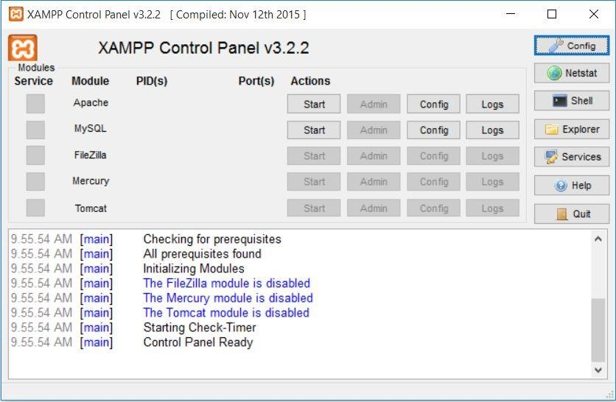XAMPP is a cost-free and open-source cross-platform web server developed by Apache Friends, it is the most favored PHP development environment which makes transitioning from a local test server to a live server possible. XAMPP is a collection of Apache distribution, MariaDB, PHP, and Perl.

**Figure 5.3: XAMPP interface**

# 5.4 ARDUINO IDE

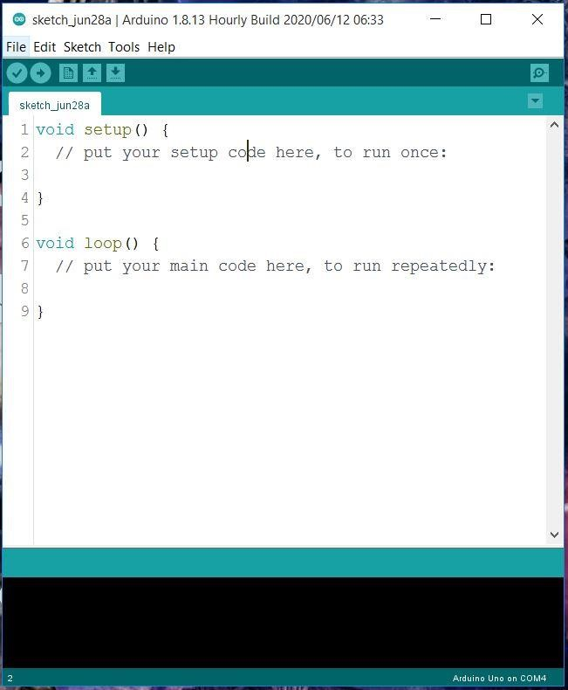The Arduino Integrated Development Environment (IDE) encompasses a text editor for writing code, it connects to the Arduino and Genuino hardware to upload programs and transmit with them. The programs are written using IDE are knows as sketches. And the file extension of the program is “.ino”. Like other editors, Arduino IDE has also featured for cutting/pasting and for searching/replacing text. The console of IDE provide error messages and other information, and the bottom right-hand corner of the window displays the configured board and serial port. The toolbar buttons allow you to verify and upload programs, create, open, and save sketches, and open the serial monitor.

**Figure 5.4: Arduino IDE**

# 5.5 VISUAL STUDIO CODE

Visual Studio Code, also commonly referred to as VS Code, is source code editor made by [Microsoft](https://en.wikipedia.org/wiki/Microsoft) with the [Electron Framework](https://en.wikipedia.org/wiki/Electron_(software_framework)), for [Windows](https://en.wikipedia.org/wiki/Windows), [Linux](https://en.wikipedia.org/wiki/Linux) and [macOS](https://en.wikipedia.org/wiki/MacOS). Features include support for [debugging](https://en.wikipedia.org/wiki/Debugging), [syntax highlighting](https://en.wikipedia.org/wiki/Syntax_highlighting), [intelligent code completion](https://en.wikipedia.org/wiki/Intelligent_code_completion), [snippets](https://en.wikipedia.org/wiki/Snippet_(programming)), [code](https://en.wikipedia.org/wiki/Code_refactoring) [refactoring](https://en.wikipedia.org/wiki/Code_refactoring), and embedded [Git](https://en.wikipedia.org/wiki/Git). Users can change the [theme](https://en.wikipedia.org/wiki/Theme_(computing)), [keyboard shortcuts](https://en.wikipedia.org/wiki/Keyboard_shortcut), preferences, and install [extensions](https://en.wikipedia.org/wiki/Plug-in_(computing)) that add functionality. Visual Studio Code was ranked the most popular developer environment tool among 71,010 respondents, with 74.48% reporting that they use it.

Visual Studio Code was first announced on April 29, 2015, by Microsoft at the 2015 [Build](https://en.wikipedia.org/wiki/Build_(developer_conference)) conference. A [preview](https://en.wikipedia.org/wiki/Technical_preview) build was released shortly thereafter. On November 18, 2015, the source of Visual Studio Code was released under the [MIT License](https://en.wikipedia.org/wiki/MIT_License), and made available on [GitHub](https://en.wikipedia.org/wiki/GitHub). Extension support was also announced. On April 14, 2016, Visual Studio Code graduated from the [public preview](https://en.wikipedia.org/wiki/Beta_software) stage and was [released to the Web](https://en.wikipedia.org/wiki/Software_release_life_cycle#Web_release). Microsoft has released most of Visual Studio Code's [source code](https://en.wikipedia.org/wiki/Source_code) on [GitHub](https://en.wikipedia.org/wiki/GitHub) under the permissive [MIT](https://en.wikipedia.org/wiki/MIT_License) [License](https://en.wikipedia.org/wiki/MIT_License), while the releases by Microsoft are proprietary [freeware](https://en.wikipedia.org/wiki/Freeware).

Visual Studio Code is a source-code editor that can be used with a variety of languages, including [C](https://en.wikipedia.org/wiki/C_(programming_language)), [C#](https://en.wikipedia.org/wiki/C_Sharp_(programming_language)), [C++,](https://en.wikipedia.org/wiki/C%2B%2B) [Fortran](https://en.wikipedia.org/wiki/Fortran), [Go](https://en.wikipedia.org/wiki/Go_(programming_language)), [Java](https://en.wikipedia.org/wiki/Java_(programming_language)), [JavaScript](https://en.wikipedia.org/wiki/JavaScript), [Node.js](https://en.wikipedia.org/wiki/Node.js), [Python](https://en.wikipedia.org/wiki/Python_(programming_language)), [Rust](https://en.wikipedia.org/wiki/Rust_(programming_language)). It is based on the [Electron](https://en.wikipedia.org/wiki/Electron_(software_framework)) framework, which is used to develop [Node.js](https://en.wikipedia.org/wiki/Node.js) [web applications](https://en.wikipedia.org/wiki/Web_application) that run on the [Blink layout engine](https://en.wikipedia.org/wiki/Blink_layout_engine). Visual Studio Code employs the same editor component (codenamed "Monaco") used in [Azure DevOps](https://en.wikipedia.org/wiki/Azure_DevOps_Server) (formerly called Visual Studio Online and Visual Studio Team Services).

Out of the box, Visual Studio Code includes basic support for most common programming languages. This basic support includes [syntax highlighting](https://en.wikipedia.org/wiki/Syntax_highlighting), [bracket](https://en.wikipedia.org/wiki/Bracket_matching) [matching](https://en.wikipedia.org/wiki/Bracket_matching), [code folding,](https://en.wikipedia.org/wiki/Code_folding) and configurable snippets. Visual Studio Code also ships with [IntelliSense](https://en.wikipedia.org/wiki/Intelligent_code_completion) for JavaScript, TypeScript, [JSON](https://en.wikipedia.org/wiki/JSON), [CSS,](https://en.wikipedia.org/wiki/CSS) and [HTML,](https://en.wikipedia.org/wiki/HTML) as well as debugging support for Node.js. Support for additional languages can be provided by freely available extensions on the VS Code Marketplace.

Instead of a project system, it allows users to open one or more directories, which can then be saved in workspaces for future reuse. This allows it to operate as a [language-agnostic](https://en.wikipedia.org/wiki/Language-agnostic) code editor for any language. It supports many programming languages and a set of features that differs per language. Unwanted files and folders can be excluded from the project tree via the settings. Many Visual Studio Code features are not exposed through menus or the user interface but can be accessed via the command palette.

Visual Studio Code can be extended via [extensions](https://en.wikipedia.org/wiki/Plug-in_(computing)), available through a central repository. This includes additions to the editor and language support. A notable feature is the ability to create extensions that add support for new [languages,](https://en.wikipedia.org/wiki/Programming_language) [themes](https://en.wikipedia.org/wiki/Theme_(computing)), [debuggers](https://en.wikipedia.org/wiki/Debugger), [time travel](https://en.wikipedia.org/wiki/Time_travel_debugging) [debuggers](https://en.wikipedia.org/wiki/Time_travel_debugging), perform [static code analysis](https://en.wikipedia.org/wiki/Static_code_analysis), and add [code linters](https://en.wikipedia.org/wiki/Lint_(software)) using the [Language Server](https://en.wikipedia.org/wiki/Language_Server_Protocol) [Protocol](https://en.wikipedia.org/wiki/Language_Server_Protocol).

**CHAPTER 6**

**SYSTEM DESIGN**

* 1. **SYSTEM ARCHITECTURE**

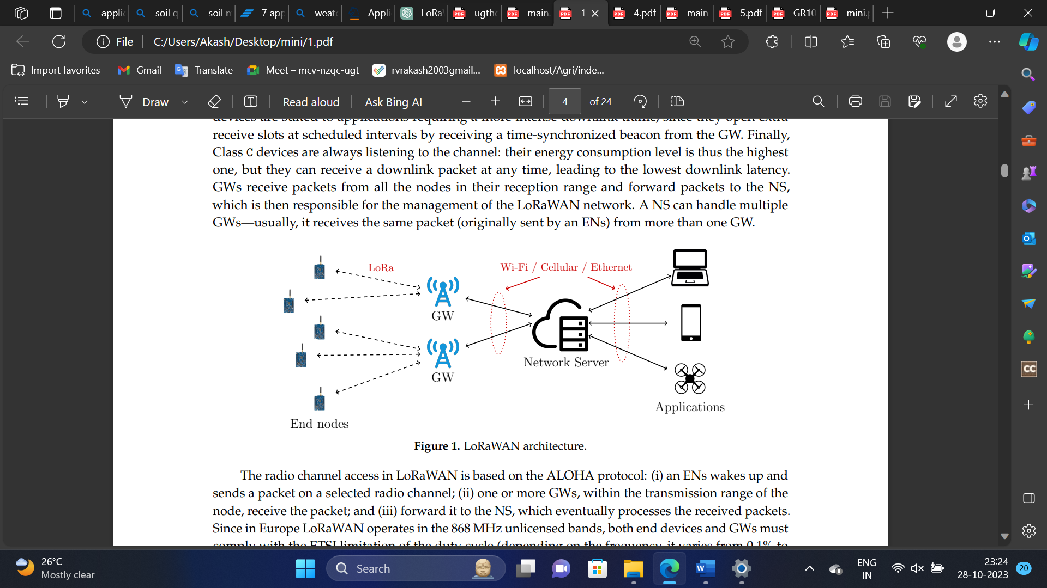

**Figure 6.1: LoRaWAN architecture**

The LoRaWAN architecture for smart agriculture deploys a network of low-power end devices, equipped with various sensors, across vast agricultural landscapes. These sensors collect essential data on soil moisture, weather conditions, crop health, and more, while transmitting it over long distances to strategically placed LoRa gateways. The network server manages data processing and security, ensuring the information reaches the application server where it's analyzed and integrated into agricultural practices. With efficient power management and long-range connectivity, LoRaWAN empowers precision agriculture, enabling farmers to make data-driven decisions, conserve resources, and optimize crop yields while reducing operational costs and environmental impact.

* 1. **LoRaWAN GATEWAY**

A LoRaWAN gateway equipped with a 16x2 LCD and a buzzer acts as a bridge between LoRa end devices and the cloud, enhancing IoT applications, especially in scenarios like smart agriculture or industrial monitoring. The gateway collects data wirelessly from LoRa end devices deployed in the field, such as sensors measuring soil moisture or temperature. Upon receiving this data, the gateway processes and packages it before transmitting the information securely to the cloud server via an internet connection.

Simultaneously, the 16x2 LCD provides real-time data visualization, offering on-site monitoring capabilities, while the buzzer serves as an alert system, generating audible notifications in response to specific events or sensor 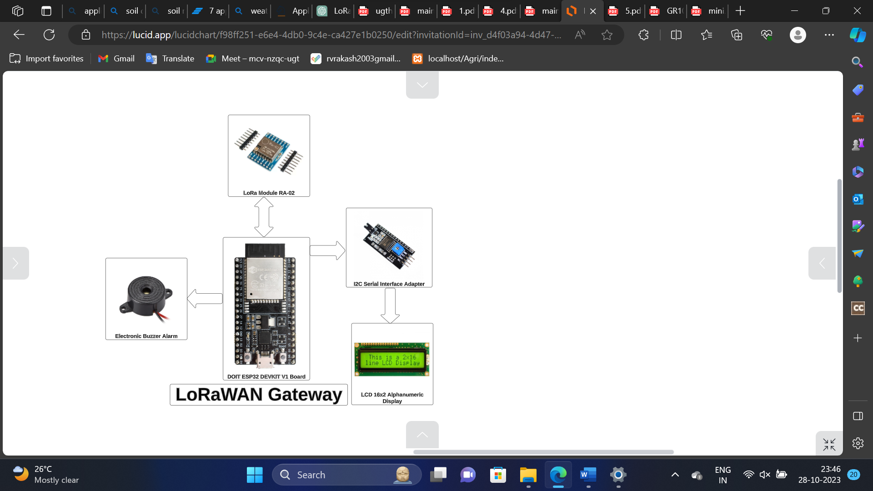thresholds being crossed.

**Figure 6.2: LoRaWAN Gateway**

* 1. **LoRaWAN ENDNODE**

LoRa end node utilizes an ESP32 board, incorporating soil moisture, LDR (Light Dependent Resistor), rain, and DHT11 sensors to collect environmental data. The ESP32 board processes the sensor data and communicates with the LoRaWAN gateway. The soil moisture sensor measures soil dampness, the LDR sensor detects light intensity, the rain sensor identifies precipitation, and the DHT11 sensor monitors temperature and humidity. Once these sensor values are obtained, the ESP32 board uses LoRaWAN technology to securely transmit this data to the LoRaWAN gateway. From there, the gateway processes the information, displays it on the 16x2 LCD screen, and triggers the buzzer for alerts when specific conditions, such as low soil moisture or heavy rainfall, are detected. Additionally, the gateway forwards the collected data to the cloud, enabling remote monitoring and analysis for smart agriculture or other related applications.

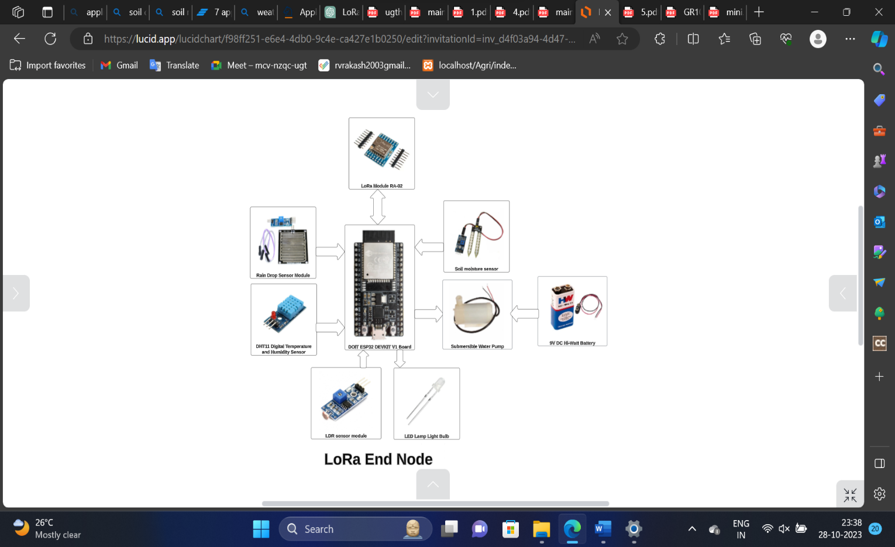

**Figure 6.3: LoRaWAN End Node**

* 1. **COMPONENTS REQUIRED**

**Table 6.1 Components used in this project**

|  |  |  |
| --- | --- | --- |
| **S.NO** | **COMPONENT** | **QUANTITY** |
| 1. | DOIT ESP32 DEVKIT V1 BOARD | 2 |
| 2. | LoRa SX1278 RA02 | 2 |
| 3. | LoRa ANTENNA | 2 |
| 4. | LDR SENSOR | 1 |
| 5. | DHT11 TEMPERATURE AND HUMIDITY SENSOR | 1 |
| 6. | SOIL MOISTURE SENSOR | 1 |
| 7. | LIQUID CRYSTAL DISPLAY (LCD) 16X2 | 1 |
| 8. | I2C MODULE | 1 |
| 9. | RELAY | 1 |
| 10. | SUBMERSIBLE WATER PUMP | 1 |
| 11. | RAINDROP SENSOR | 1 |
| 12. | BREADBOARD 840 POINT | 2 |

* + 1. **DOIT ESP32 DEVKIT V1 BOARD**

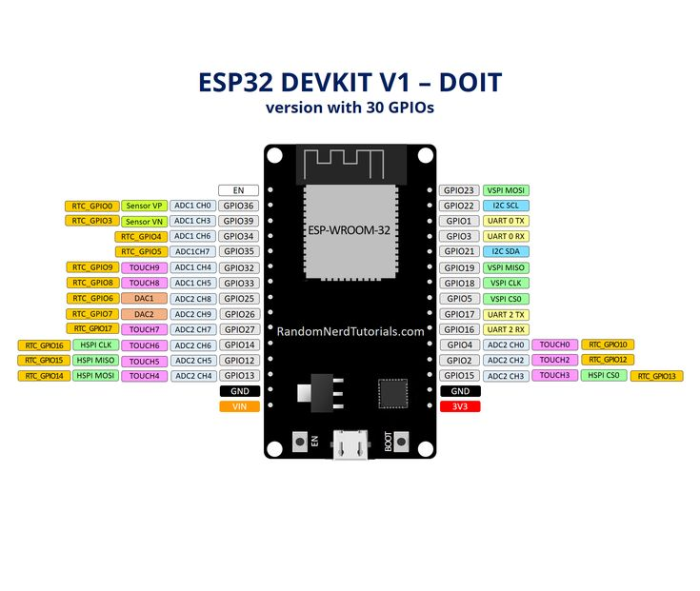The ESP32 is a series of chip microcontrollers developed by Espressif.

**Figure 6.4: DOIT ESP32 DEVKIT V1 BOARD**

**Table 6.2 Specifications OF ESP32 DEVKIT V1 DOIT**

|  |  |
| --- | --- |
| **Number of cores** | 2 (dual core) |
| **Wi-Fi** | 2.4 GHz up to 150 Mb/s |
| **Bluetooth** | BLE (Bluetooth Low Energy) and legacy Bluetooth |
| **Architecture** | 32 bits |
| **Clock frequency** | Up to 240 MHz |
| **RAM** | 512 KB |
| **Pins** | 30, 36, or 38 (depending on the model) |
| **Peripherals** | Capacitive touch, ADC (analog to digital converter), DAC (digital to analog converter), I2C (Inter-Integrated Circuit), UART (universal asynchronous receiver/transmitter), CAN 2.0 (Controller Area Netwokr), SPI (Serial Peripheral Interface), I2S (Integrated Inter-IC Sound), and more. |

* + 1. **LoRa SX1278 RA02**

The LoRa SX1278 RA02 works with SPI communication protocol so it can be used with any micro microcontroller that supports SPI communication protocol. It is mandatory to use an antenna along with the module else it might damage the module permanently. The module should be powered only with 3.3V, and the operating voltage is 3.3V, and the frequency is 433 MHz and transmits and receives packets up to 256 bytes. Here we are not legally allowed to use the 433MHz frequency module for a long time other than for educational purposes.

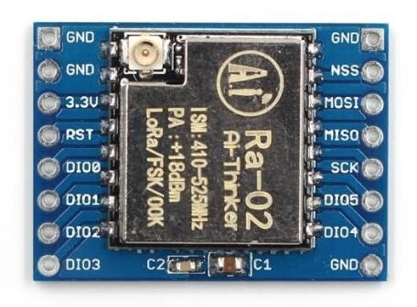

**Figure 6.5: LoRa SX1278 RA02**

* + 1. **LoRa ANTENNA**

Using the LoRa or Sigfox connectivity on the LoPy4 you are going to need to connect a special antenna before beforehand otherwise you risk damaging the device. This universal LoRa and Sigfox Antenna Kit can also be used with LoPy, SiPy, and FiPy IoT development boards on top of the LoPy4.

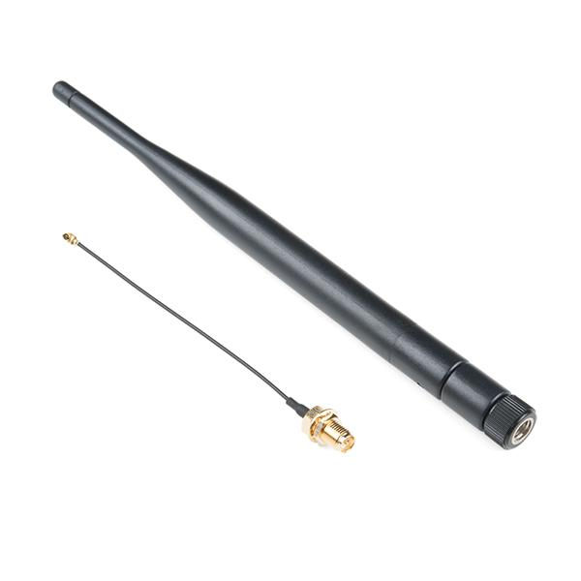

**Figure 6.6: LoRa Antenna**

* + 1. **LDR SENSOR**

In this project we use, LDR (Light dependent Resistor) as a Light Sensor. This device is use to take data about light. It takes data from sunlight to tell about the Quantity of light (by using both concept of density and intensity).

**Why we using LDR or Photo-resistor?**

LDR or photo-resistor can be used to measure the quantity of light that reaches a piece of land.

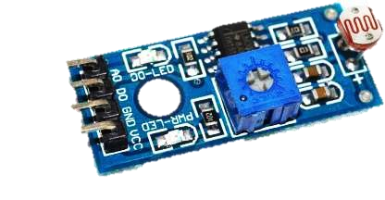Important Note: When Percentage is zero it means there is no light, when Percentage is 100% it means lot of light.

**Figure 6.7: LDR Sensor (Light Dependent Resistor)**

The quantity of light that a sensor known as an LDR (Light Dependent Resistor) senses causes it to alter its electrical resistance. After that, the amount of light is transformed into a 10-bit digital number and finally into a percentage out of 100.

**Two Cases in LDR-Sensor:**

Case I: When LDR Sensor Sense/Detect Some Amount of Light.

Case II: When LDR Sensor Sense/Detect no Light.

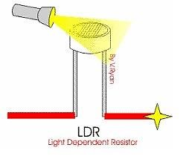**Case I:** When LDR Sensor detect some amount of light:

**Figure 6.8: LDR sensor sense Some amount of Light**

In first case, when LDR sensor sense Some quantity of Light the Output will be High and Show Some Output. The value of output is greater than 1 and the value Between 1 and 100.

**Case II**: When LDR Sensor detect no light.

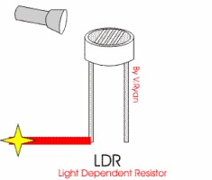

**Figure 6.9: LDR sensor sense no Light**

In Second case, when LDR sensor sense no Light the Output will be LOW and Show Some Output. The value of output is Zero.

* + 1. **DHT11 TEMPERATURE AND HUMIDITY SENSOR**

This device is use to take data about Temperature and Humidity. Temperature is Important factor when crops are beginning to ready. When temperature exceed the maximum level it will be dangerous for crops growth, health and Quality.

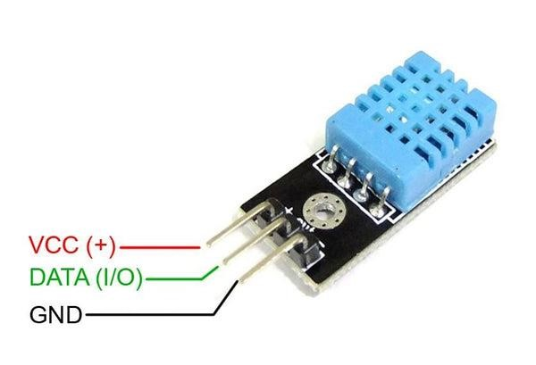Accordingly, we use DHT-11 sensor to measure the temperature and Humidity. This sensor take data from its surrounding. All data in its surrounding in analog form and this analog data send to micro-controller and change into digital form in sequence.

**Figure 6.10: Temperature and Humidity Sensor**

**Why we are using Temperature and Humidity Sensor?**

Just like humans and other living things, plants have evolved to be sensitive to changes in temperature and humidity. In order to keep comfortable, we get ready for the impending winter, summer, or rainy seasons. Similar to how people prepare for the next seasons, plants do the same, either to adjust for the worse or to blossom with fruits and blooms.

The DHT11 digital sensor is used to measure temperature and humidity in order to determine the start of crop growth or fruit production, as these variables play a significant role in the process.

**Pin Configuration:**

The pin arrangement of the DHT-11 sensor, which is available from several manufacturers, can change from the one seen in the circuit diagram. Determining the appropriate Vcc, GND, and output/Data Pins for your particular DHT-11 sensor is so crucial.

**Table 6.3 Pin Configuration of DHT11**

|  |  |  |
| --- | --- | --- |
| Sr. No | Pins | Connection |
| 1 | Vcc | +3.3 V – 5.5 V (Input High) |
| 2 | GND | Ground (LOW) |
| 3 | Data Pin | Connected with ESP32 |

* + 1. **SOIL MOISTURE SENSOR**

A tool that gauges the quantity of water in the soil is called a soil moisture sensor. A soil moisture sensor may be used in an IoT-based smart agriculture monitoring system to give farmers and growers vital information on the water requirements of their crops. Here are some reasons why soil moisture sensor is useful in this context:

1. **Automation of Irrigation System:** By measuring the soil moisture levels, the sensor can be used to control the irrigation system to automatically provide water to the crops only when it is needed, improving the efficiency of water usage and reducing waste.
2. **Real-time monitoring:** The sensor can be connected to the internet through a microcontroller or gateway and the data can be monitored in real-time using a mobile application or web portal, enabling farmers to make informed decisions about irrigation.
3. **Early warning:** By monitoring the soil moisture levels, the sensor can provide early warning of potential issues, such as dry soil or waterlogging, allowing farmers to take action before the problem becomes severe.
4. **Water saving:** By providing accurate data about the soil moisture, the sensor can help farmers to save water and reduce the water consumption.

Overall, Soil moisture sensor is a key component in the IoT-based smart agriculture monitoring system as it plays an important role in providing accurate information about the water needs of the crops, allowing farmers to make informed decisions about irrigation.

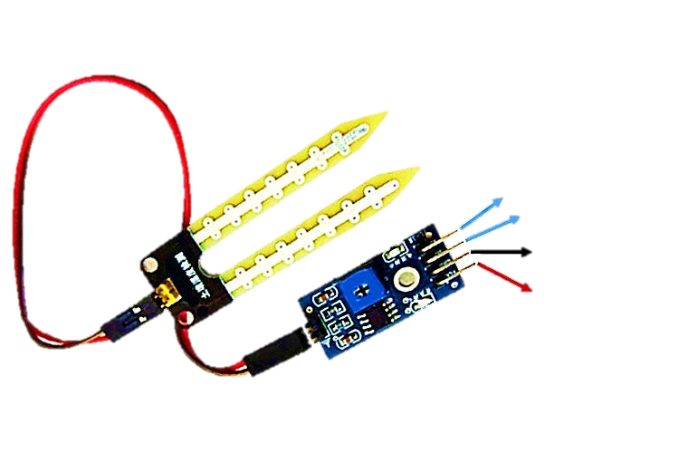

Analog

Digital

GND

**Figure 6.11: Soil Moisture Sensor**

**Pin Configuration:**

The pin configuration of a soil moisture sensor can vary depending on the specific sensor being used. Some soil moisture sensors have additional pin like digital output pin and power supply pin like 3.3V or 5V. Please note that the pin configuration may vary depending on the specific soil moisture sensor used, it's always a good idea to check the datasheet before using it. And also make sure that the power supply voltage is matched with the sensor voltage rating. However, here is an example of a common pin configuration for a soil moisture sensor in following below table.

**Table 6.4 Pin Configuration of Soil moisture Sensor**

|  |  |  |
| --- | --- | --- |
| Sr. No | Pins | Connection |
| 1 | Vcc | +3.3 V – 5.5 V (Input High) |
| 2 | GND | Ground (LOW) |
| 3 | Analog Pin (A0) | Connected with ESP32 |
| 4 | Digital Pin (NA) | Not Used |

* + 1. **LIQUID CRYSTAL DISPLAY (LCD) 16X2**

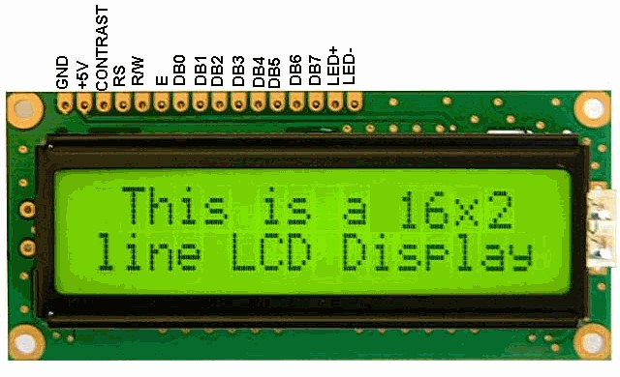An LCD 16x2 display can be used in an IoT-based smart agriculture monitoring system to display information such as temperature, humidity, and soil moisture levels. This allows farmers to easily monitor the conditions in their fields without having to constantly check their devices. The 16x2 format of the LCD display allows for the display of two rows of 16 characters, providing ample space for displaying multiple pieces of information at once. Additionally, LCD displays consume less power than other types of displays, making them well-suited for use in remote, battery-powered monitoring systems.

**Figure 6.12: Liquid Crystal Display (16x2)**

* + 1. **I2C MODULE**

The I2C (Inter-Integrated Circuit) shield can be used in an IoT-based smart agriculture monitoring system in conjunction with an LCD 16x2 display to allow for communication between the microcontroller and the display.

The I2C shield allows for communication between the microcontroller and the LCD display using the I2C protocol. This protocol is a popular choice for communication between devices because it uses a simple two-wire interface (SDA and SCL) and allows for multiple devices to be connected to the same bus, reducing the number of required pins on the microcontroller.

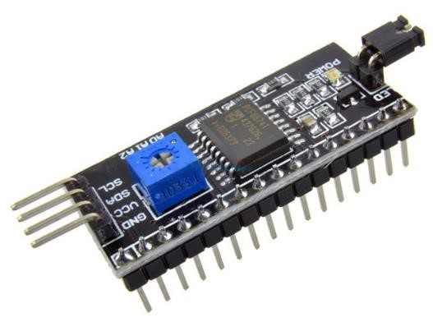Additionally, using an I2C shield, it can also add more functionality to the project like providing power to the device, adding more sensors, etc. Also, it can save the pin number of the microcontroller since the I2C shield only uses 2 pins for communication.

**Figure 6.13: I2c Module**

**Pin Configuration:**

Here is a table showing the pin configuration of a typical I2C module:

**Table 6.5 Pin Configuration detail of I2c Module**

|  |  |
| --- | --- |
| **SDA:** | Serial Data Line |
| **SCL:** | Serial Clock Line |
| **VCC:** | Power Supply (3.3V or 5V) |
| **GND:** | Ground |

* + 1. **RELAY**

Relays are electrically powered switches that may be used to control circuits with high voltage or current using signals with lower voltage or current. In an IoT-based smart agriculture monitoring system, relays can be used to control various devices such as irrigation systems, lighting systems, and ventilation systems based on the information collected by the sensors.

1. **Isolation:** Relays provide electrical isolation between the control circuit and the load circuit, which can protect the microcontroller and other low-voltage components from damage caused by high-voltage or high-current circuits.
2. **Control High Voltage/Current:** Relays can control high voltage and high current loads with a low voltage control signal, which is compatible with microcontrollers and other low-voltage electronic devices.
3. **Safety:** Relays can be used to control potentially dangerous equipment or systems, such as electrical heating elements, in a safe manner.

Relays are widely used in IoT projects to control devices, automate processes, and ensure safety.

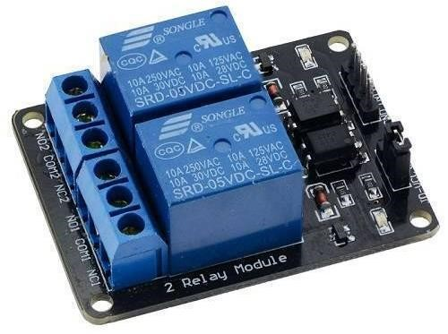

**Figure 6.14: Double Channel Relay**

**Pin Configuration:**

Here is a table showing the pin configuration of a typical relay:

**Table 6.6 Pin Configuration of Relay**

|  |  |
| --- | --- |
| **Pin** | **Description** |
|  | **Pin Configuration where Load is Connected** |
| **Coil** | The pin where the current flows to activate the relay, often connected to a microcontroller or other control circuit |
| **Common** | The common terminal, connected to either the normally open (NO) or normally closed (NC) contact |
| **Normally Open (NO)** | The terminal that is open (not connected) when the relay is not energized. |
| **Normally Closed (NC)** | The terminal that is closed (connected) when the relay is not energized. |
|  | **Pins Connected with Controller** |
| **VCC** | Power Supply (DC +5V) |
| **GND** | Ground |
| **INT (Signal)** | The signal pin is mainly used for controlling the relay. |

* + 1. **SUBMERSIBLE WATER PUMP**

In an IoT-based smart agriculture monitoring system, a water pump can be used to automatically provide water to crops based on the information collected by the sensors.

**Watering in Dry area:**

Water pumps can be used in areas where water is scarce or difficult to access, making it possible to bring water to the crops even in dry conditions. Overall, Water pump is an important component in the smart agriculture monitoring system as it plays a vital role in providing water to the crops at the right time, in the right quantity and in the right place. Special program fed into controller. Controller automatically turn on the water pump when moisture percentage is less than 50% and turn off automatically when moisture level is greater than 70% percentage. We can vary these level of turn on and turn off by do changing in programming of controller.

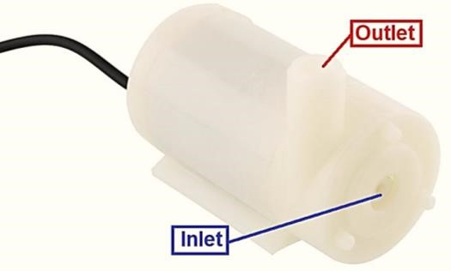

**Figure 6.15: Submersible Water Pump**

* + 1. **BUZZER**

The Buzzer connected to an Arduino is an output device that produces audible sounds or tones. It can be used to provide audio feedback to the user or to alert the user of a specific event.

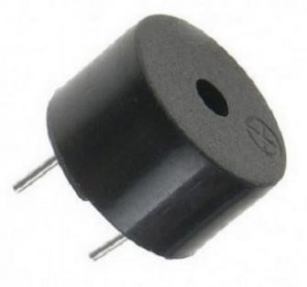In the context of a gas sensor, the buzzer can be used to alert the user when a certain level of gas concentration is detected. For example, if the gas sensor is detecting a dangerous level of gas, the Arduino can activate the buzzer to produce a loud sound to alert the user to take appropriate action, such as turning off the gas supply or evacuating the area.

**Figure 6.16: Buzzer**

* + 1. **RAINDROP SENSOR**

The rain drop sensor module is a smart and low-cost rain sensing device. It has two parts i.e. a rain sensing pad and a control board. The sensitive sensing pad detects any water present on it while the control board reads these signals and can also binarize them. The rain drop module has a major application in the automobile industry. It can be used to monitor the rain and send closure requests to shutters or windows whenever the rain is detected.

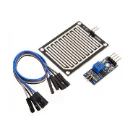**Figure 6.17: Raindrop Sensor**

### Pin Configuration

**Table 6.7 Pin Configuration of Raindrop sensor**

|  |  |
| --- | --- |
| Pin Name | Function |
| VCC | Positive power supply pin. It powers the sensor. |
| GND | Reference potential pin |
| D0 | Digital output pin. It gives the digital output of the internal comparator circuit. |
| A0 | Analog output pin. It serves to give analog signals between 0-5 Volts . |

* + 1. **BREADBOARD 840 POINT**

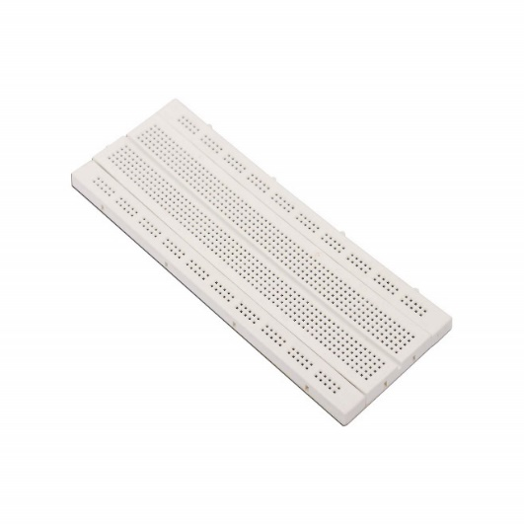A breadboard is a white rectangular board with small embedded holes to insert electronic components. It is commonly used in electronics projects as a prototype that acts as a construction base of electronics. 840 Tie Point Solderless Breadboard. A breadboard is used to make up temporary circuits for testing or to try out an idea.

**Figure 6.18: Breadboard 840 points**

**CHAPTER 7**

**SYSTEM IMPLEMENTATION**

* 1. **MODULE SPECIFICATION**
* Installing The ESP32 and Lora Library in Arduino IDE
* Implementation Of the ESP32 Lorawan Gateway
* Implementation Of the ESP32 Sensor Node
* Prepare Database and Webpage
* 000Webhost Web Hosting
  1. **MODULE DESCRIPTION**

After the study in the agriculture sector, fields are mainly available in rural areas. Moreover, the farmers need to control some components like motor, etc. and some basic information about the field like, how much moisture is available in the soil and how much temperature is there? For getting this kind of control and information, they require to use wireless technology. After that, we are starting a survey and study about different wireless technology available in the market like Wi-Fi, Bluetooth, Zigbee, and many more. And finally, we are selecting one best wireless technology for the agriculture sector. We have selected LoRa wireless technology for the agriculture sector. because it fulfills all requirements for making a smart agriculture system.

* + 1. **Installing The ESP32 and Lora Library In Arduino IDE**

In the first step, we are going to do some basic interaction between LoRa and ESP32. For doing that we require a number of two ESP32, and two LoRa RA02 SX1278 modules. There is mandatory to operate the LoRa module with antenna, else output power will damage the module. Here we are using a 433Mhz LoRa module, so my antenna is also rated for 433Mhz. For doing this interaction, we need to create one transmitter and one receiver. **Installing the ESP32 in Arduino IDE**

To be able to program the ESP32 using Arduino IDE, you need to add support for the ESP32 boards. Follow the next steps:

**Go to File > Preferences.**

Enter the following into the “Additional Board Manager URLs” field. This will add support for ESP32 and ESP8266 boards as well.

**https://raw.githubusercontent.com/espressif/arduino-esp32/gh-pages/package_esp32_index.json,http://arduino.esp8266.com/stable/package_esp8266com_index.json**

**Open the Boards Manager. Go to Tools > Board >Boards Manager…**

Search for ESP32 and install the “ESP32 by Espressif Systems “: That’s it. It will be installed after a few seconds.

After this, restart your Arduino IDE.

**Then, go to Tools > Board and check that you have ESP32 boards available.**

Now, you’re ready to start programming your ESP32 using Arduino IDE.

* + 1. **Implementation of the ESP32 Lorawan Gateway**

To create a LoRaWAN gateway, we need an ESP32 development board and a LoRa transceiver module (we are using SX1278 (Ra-02) module). The ESP32 is responsible for receiving LoRaWAN packets from sensor nodes and forwarding them to the LoRaWAN network server like thingspeak. Setting up the gateway involves configuring the LoRa module, connecting it to the ESP32, and programming the ESP32 with the appropriate firmware.

**Figure 7.1: LoRa with ESP32 Transmitter**

**Table 7.1 ESP32 to LoRa Interaction Tx**

|  |  |
| --- | --- |
| **LoRa SX1278 Module** | **ESP32 Board** |
| VCC | 3.3V |
| Gnd | Ground |
| MOSI | GPIO 23 |
| MISO | GPIO 19 |
| SCLK | GPIO 18 |
| NSS | GPIO 4 |
| RST | GPIO 5 |
| DIO0 | GPIO 2 |

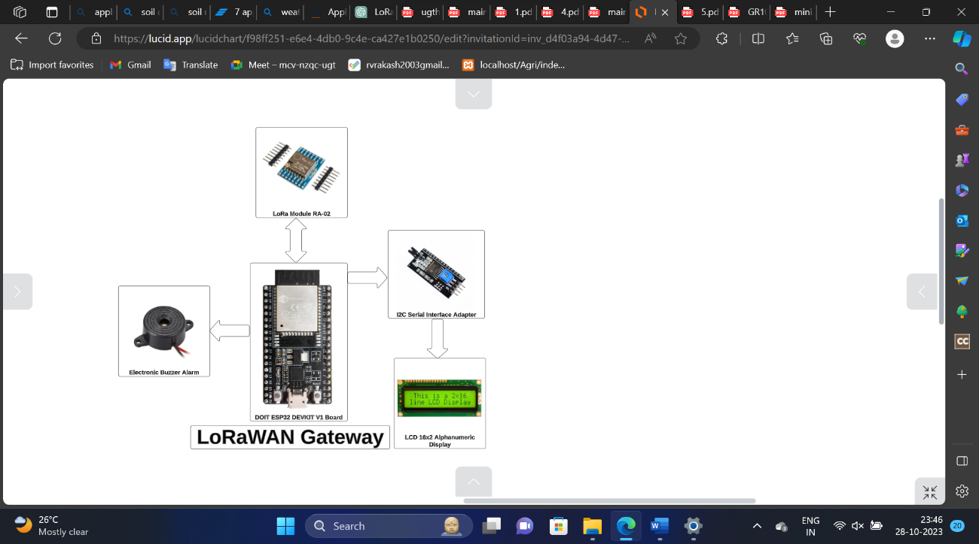As we discussed in chapter 4 topic number 4.2, we are using the same thing here. Use the ESP32 module in the receiving side, so we easily upload and store the received data of soil moisture sensor, LDR, Raindrop, Temperature and Humidity values on the database.

**Figure 7.2: Block Diagram of Receiver with Gateway**

Using a website or android application, the farmers can remotely control the motor. Here system receiver work as a transmitter. Now our transmitter is a collection of ESP32, LoRa SX1278 with antenna, 5V power supply, and controlling web page.

* + 1. **Implementation of the ESP32 Sensor Node**

The sensor is a versatile environmental sensor capable of measuring temperature, humidity, and barometric pressure. To create the sensor node, we integrate the sensor with an ESP32. The sensor node is programmed to collect data from the sensor and transmit it to the gateway using LoRaWAN technology.

**Table 7.2 ESP32 to LoRa Interaction Rx**

|  |  |
| --- | --- |
| LoRa SX1278 Module | ESP32 Board |
| VCC | 3.3V |
| **Gnd** | Ground |
| MOSI | GPIO 23 |
| **MISO** | GPIO 19 |
| SCLK | GPIO 18 |
| **NSS** | GPIO 4 |
| **RST** | GPIO 5 |
| **DIO0** | GPIO 2 |

As we discussed in chapter 3, using the DHT sensor, we get temperature and humidity. The measurement of temperature and humidity is very essential for field monitoring. So we have to connect the DHT sensor on a transmitter side. Now our transmitter is a collection of ESP32, LoRa SX1278 with antenna, DHT sensor, and 5V power supply.

DHT sensor has three different pins: a) DATA pin, b) VCC pin, c) GND pin. This sensor works with a 5V power supply, so we just need to connect the VCC pin of the DHT sensor with a 5V pin or VIN pin of ESP32 and simply connect the GND pin of DHT sensor with the GND pin of ESP32. The DATA pin of the DHT sensor is connected with any digital pin of ESP32. In my case, I am going to connect the DATA pin of DHT sensor with the D21 pin of ESP32.

The Soil Moisture sensor we measure available moisture in the soil and the measurement of soil moisture is very essential for field monitoring. So we need to connect the Soil Moisture sensor on a transmitter side. Now our transmitter is a collection of ESP32, LoRa SX1278 with antenna, Soil Moisture Sensor, and 5V power supply.

Soil moisture sensor has four different pins: A) DATA pins: i) one for analog signal, ii) one for digital signal. B) VCC pin, C) GND pin. This sensor works with a 5V power supply, so you just need to connect the VCC pin of moisture sensor with a 5V pin or VIN pin of ESP32. And simply connect the GND pin of moisture sensor with the GND pin of ESP32. The analog DATA pin of moisture sensor is connected with any analog pin of ESP32, in my case, I am going to connect analog DATA pin of moisture sensor with VP pin of ESP32

The Raindrop sensor we detect the rainfall in the environment and the measurement of rain is very essential for field monitoring. So we need to connect the Raindrop sensor on a transmitter side. Now our transmitter is a collection of ESP32, LoRa SX1278 with antenna, Raindrop Sensor, and 5V power supply.

Raindrop sensor has four different pins: A) DATA pins: i) one for analog signal, ii) one for digital signal. B) VCC pin, C) GND pin. This sensor works with a 5V power supply, so you just need to connect the VCC pin of Raindrop sensor with a 5V pin or VIN pin of ESP32. And simply connect the GND pin of Raindrop sensor with the GND pin of ESP32. The analog DATA pin of Raindrop sensor is connected with any analog pin of ESP32, in my case, I am going to connect analog DATA pin of Raindrop sensor with D35 pin of ESP32.

The LDR sensor we detect the light in the environment and the measurement of light is very essential for field monitoring. So we need to connect the LDR sensor on a transmitter side. Now our transmitter is a collection of ESP32, LoRa SX1278 with antenna, LDR Sensor, and 5V power supply.

LDR sensor has three different pins: A) DATA pins: i) one for digital signal. B) VCC pin, C) GND pin. This sensor works with a 5V power supply, so you just need to connect the VCC pin of LDR sensor with a 5V pin or VIN pin of ESP32. And simply connect the GND pin of LDR sensor with the GND pin of ESP32. The digital DATA pin of LDR sensor is connected with any digital pin of ESP32, in my case, I am going to connect digital DATA pin of LDR sensor with D15 pin of ESP32.

The LED has two different pins: A) Negative, B) Positive. Negative pin connects with the GND pin of ESP32 and the positive pin of LED connects with any digital pin of ESP32. Here, the positive pin of LED connected with D32 on ESP32.

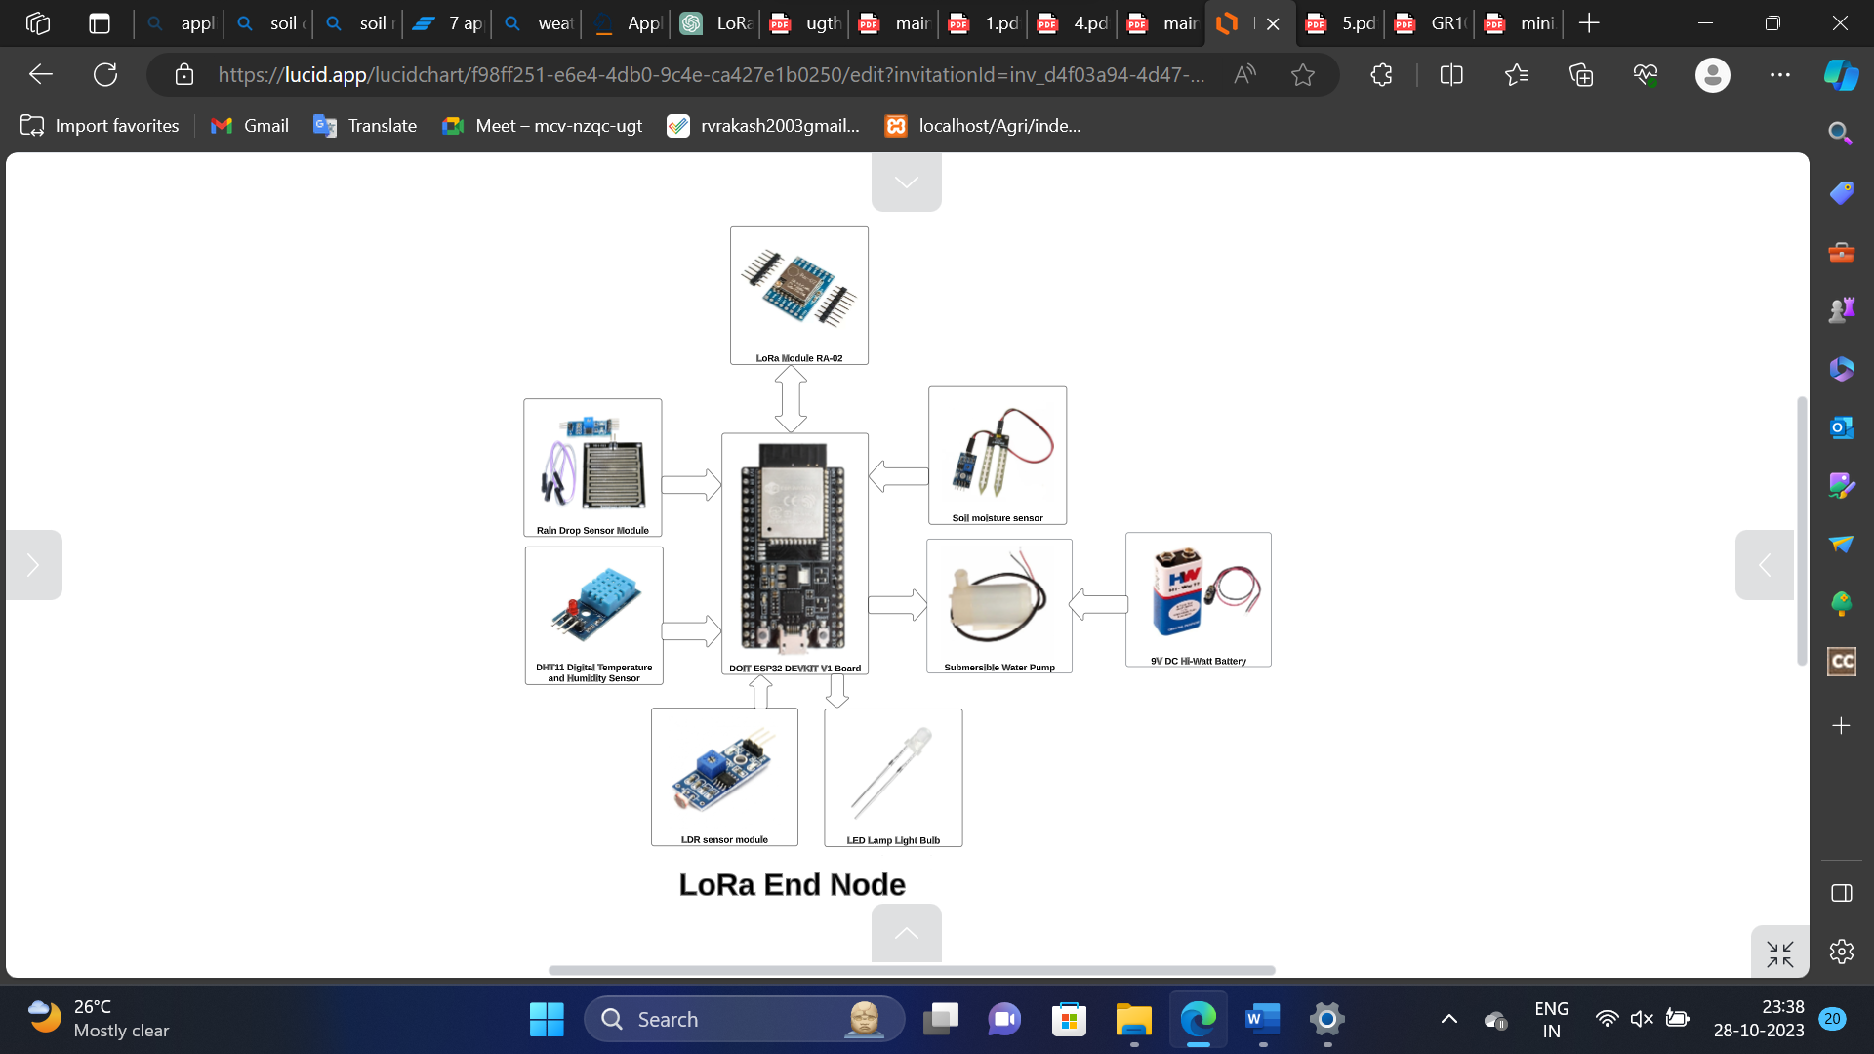Measure soil moisture levels with a sensor, and employ ESP32 to analyze the data. When the soil is dry, activate a water pump through a relay, ensuring automatic and timely irrigation.

**Figure 7.3: Block Diagram of Transmitter with Sensors**

**Table 7.3 ESP32 with Sensor interaction**

|  |  |
| --- | --- |
| SENSORS | ESP32 |
| DHT11 | **D21** |
| LDR | **D15** |
| SOIL MOISTURE | **VP** |
| RAINDROP | **D35** |
| LED | **32** |

After that, we need to program our transmitter. For that, we have to install a library of DHT in Arduino IDE, by going from Sketch à Include Library à Manage Libraries. And search for DHT. Then we are able to program it. At the beginning of the program, including the library, define DHTTYPE, and also define DHT data pin connect with Arduino, and just begin it in void setup.

* + 1. **Prepare Database and Web Page**

We want to provide remote access to farmers, so we are created one website by that farmers can easily monitor the temperature and humidity of the field. But first of all, we have to create one database. As we have seen in chapter 3, using XAMPP phpMyAdmin we do that.

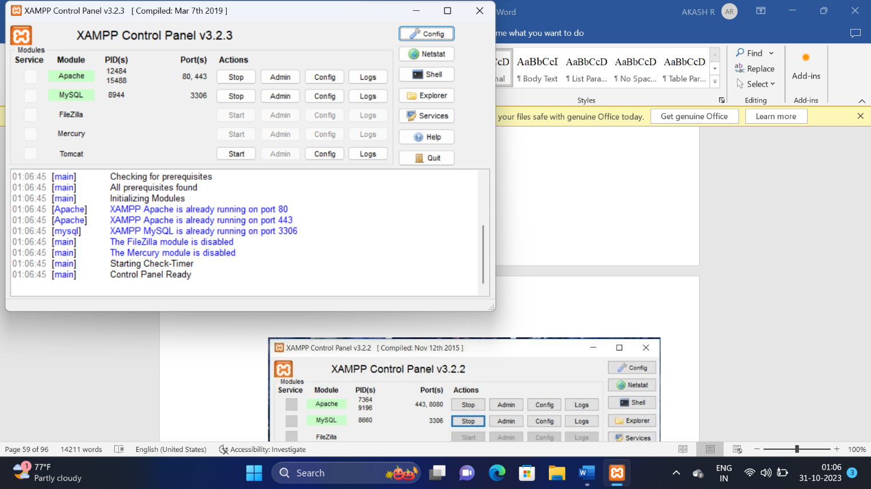In the first step we need to start Apache and MySql from XAMPP:

**Figure 7.4: XAMPP Control Panel**

Open phpMyAdmin by searching “localhost/phpMyAdmin” on a browser. And create one new database, after that create one table in that database and store the sensor value in that.

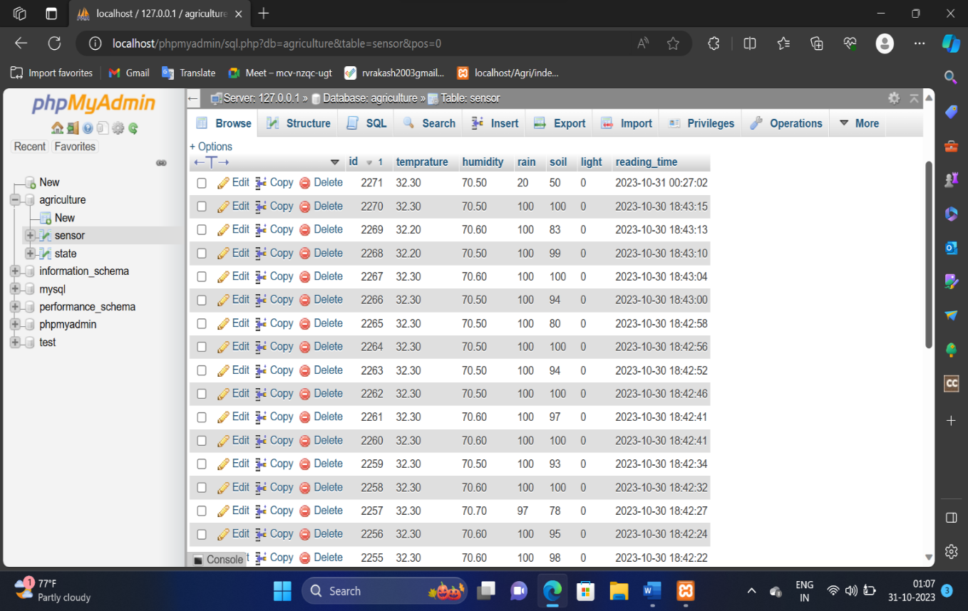**Figure 7.5: phpMyAdmin Database**

Here the database name is a “sensor”, and the table name is the “weather”. In the table we store the id number of data, then temperature, humidity, RSSI value, and date and time.

* + 1. **000Webhost Web Hosting**

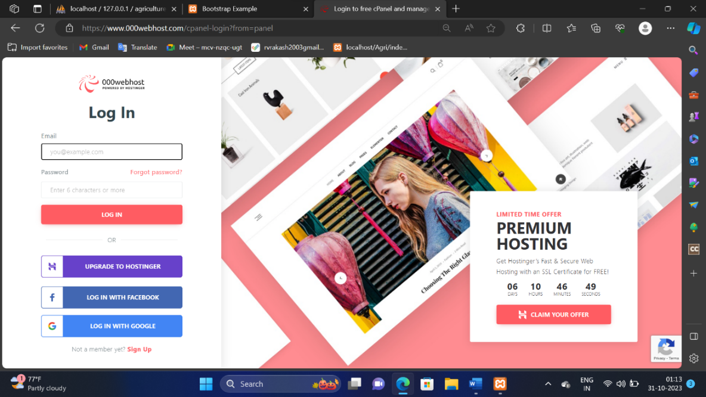000WebHost [33] is a free web hosting company and its power by hostinger. They also provide web hosting at zero charges including 99.9% uptime certified. We use this free web hosting for providing worldwide accessibility for the farmer. For that, we host the website on this web hosting. For that, we need to log in with the email id.

**Figure 7.6 Login Page of 000webhost**

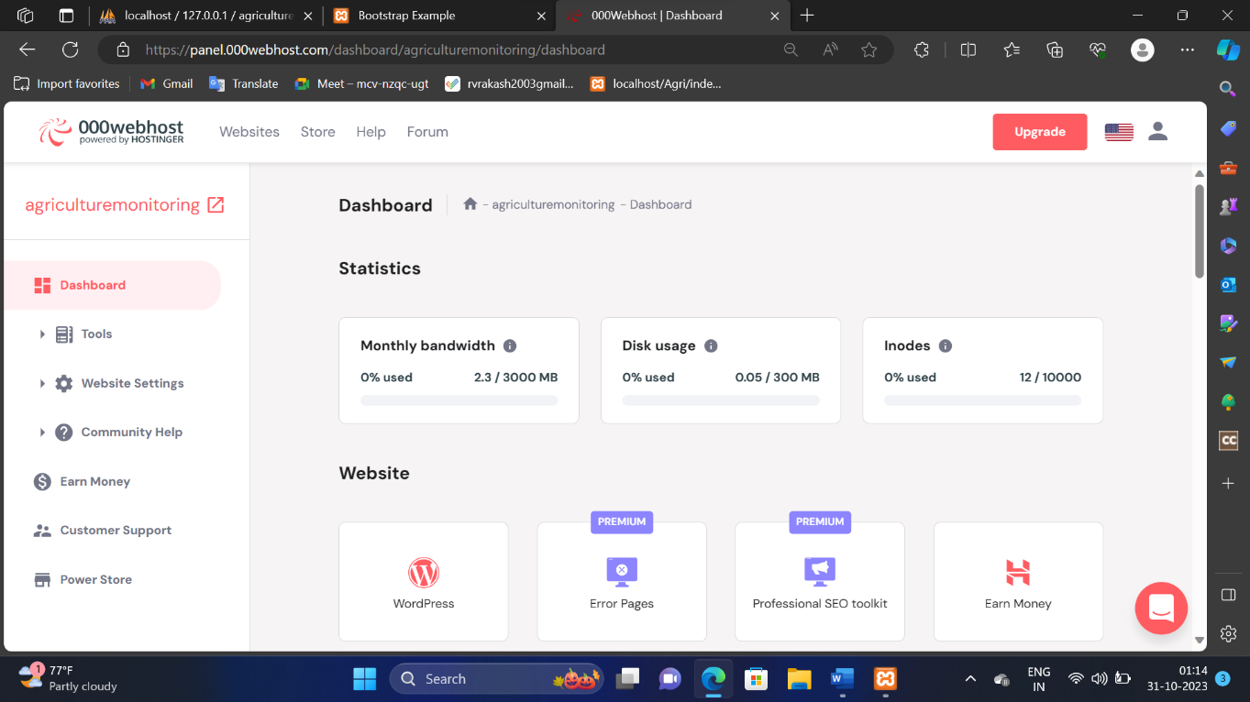After login, create a new site, for that we provide one unique name of the site and it displays a dashboard for controlling a website.

**Figure 7.7 Dashboard of 000webhost**

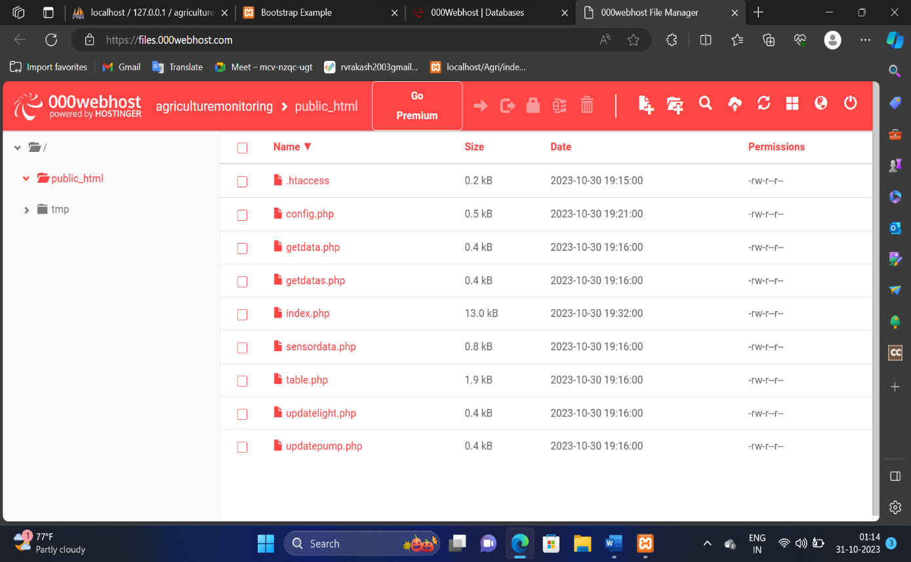For uploading website design files, select tools à file manager à upload files.

**Figure 7.8: File manager of 000webhost**

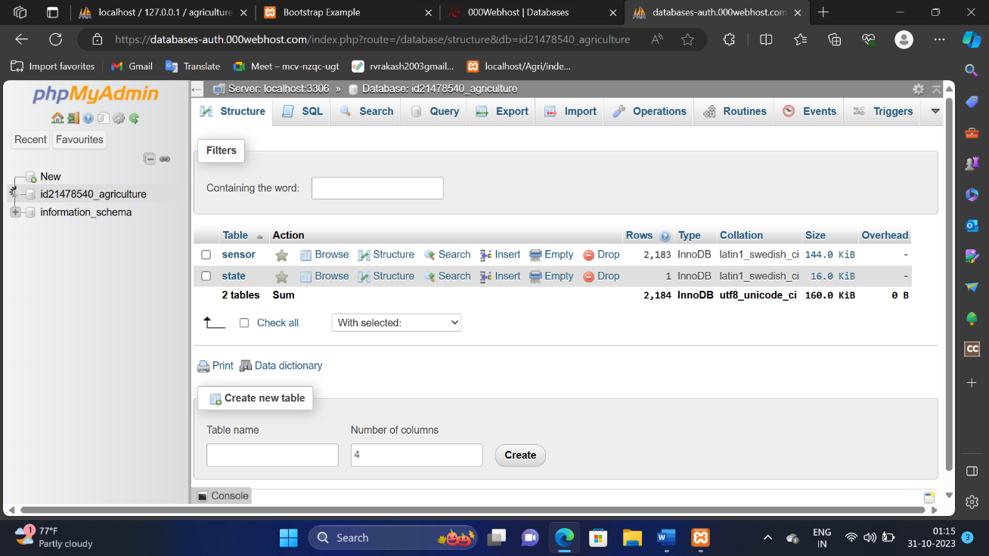Create one database for storing the sensor value on that. Go to tools à Database Manager.

**Figure 7.9 Database Manager of 000webhost**

Now our website is ready to use via the internet. Here I am attaching some screenshots of my website.

**CHAPTER 8**

**SYSTEM TESTING**

The purpose of testing is to discover errors. Testing is the process of trying to discover every conceivable fault or weakness in a work product. It provides a way to check the functionality of components, sub-assemblies, assemblies and/or a finished product It is the process of exercising software with the intent of ensuring that the Software system meets its requirements and user expectations and does not fail in an unacceptable manner. There are various types of tests. Each test type addresses a specific testing requirement.

# TYPES OF TESTS

## Unit testing

Unit testing involves the design of test cases that validate that the internal program logic is functioning properly, and that program inputs produce valid outputs. All decision branches and internal code flow should be validated. It is the testing of individual software units of the application it is done after the completion of an individual unit before integration. This is a structural testing, that relies on knowledge of its construction and is invasive. Unit tests perform basic tests at component level and test a specific business process, application, and/or system configuration. Unit tests ensure that each unique path of a business process performs accurately to the documented specifications and contains clearly defined inputs and expected results.

## Integration testing

Integration tests are designed to test integrated software components to determine if they actually run as one program. Testing is event driven and is more I concerned with the basic outcome of screens or fields. Integration tests demonstrate that although the components were individually satisfaction, as shown by successfully unit testing, the combination of components is correct and consistent. Integration testing is specifically aimed at exposing the problems that arise from the combination of components.

## Functional test

Functional tests provide systematic demonstrations that functions tested are available as specified by the business and technical requirements, system documentation, and user manuals.

Functional testing is centered on the following items:

Valid Input: identified classes of valid input must be accepted. Invalid Input: identified classes of invalid input must be rejected.

Functions: identified functions must be exercised.

Output: identified classes of application outputs must be exercised. Procedure: interfacing systems or procedures must be invoked.

Organization and preparation of functional tests is focused on requirements, key functions, or special test cases. In addition, systematic coverage pertaining to identify Business process flows; data fields, predefined processes, and successive processes must be considered for testing. Before functional testing is complete. additional tests are identified and the effective value of current tests is determined.

## System Test

System testing ensures that the entire integrated software system meets requirements. It tests a configuration to ensure known and predictable results. An example of system testing is the configuration-oriented system integration test. System testing is based on process descriptions and flows, emphasizing pre-driven process links and integration points.

## White Box Testing

White Box Testing is a testing in which in which the software tester has knowledge of the inner workings, structure and language of the software, or at least as purpose. It is purpose. It is used to test areas that cannot be reached from a black box level.

## Black Box Testing

Black Box Testing is testing the software without any knowledge of the inner workings, structure or language of the module being, tested. Black box tests, as most other kinds of tests, must be written from a definitive source document, such as specification or requirements document, such as specification or requirements document. It is a testing in which the software under test is treated, as a black box you cannot "see" into it. The test provides inputs and responds to outputs without considering how the software works:

# UNIT TESTING

Unit testing is usually conducted as part of a combined code and unit test phase of the software lifecycle, although it is not uncommon for coding and unit testing to be conducted as two distinct phases.

## Test strategy and approach

Field testing will be performed manually and functional tests will be written in detail.

## Test objectives

* + - * All field entries must work properly.
      * Pages must be activated from the identified link.
      * The entry screen, messages and responses must not be delayed.

## Features to be tested

* + - * Verify that the entries are of the correct format
      * No duplicate entries should be allowed
      * All links should take the user to the correct page.

# INTEGRATION TESTING

Software integration testing is the incremental integration testing of two of more integrated software components on a single platform to produce failures caused by interface defects.

The task of the integration test is to check that components or software applications, e.g. components in a software system or - one step up – software applications at the company level

- interact without error.

**Test Results:** All the test cases mentioned above passed successfully. No defects encountered.

# ACCEPTANCE TESTING

User Acceptance Testing is a critical phase of any project and requires significant participation by the end user. It also ensures that the system meets the functional requirements. Test Results: All the test cases mentioned above passed successfully. No defects encountered.

**CHAPTER 9**

**CONCLUSION AND FUTURE ENHANCEMENT**

* 1. **CONCLUSION**
* The system has been configured to use the LoRa module to create a smart agriculture control and monitoring system. Intelligent agricultural data collection and equipment control is supported by wireless sensor networks and network communication technologies. We've also added the ability to control and monitor the device remotely using computer software.
* For any farmer, the monitoring of information about soil moisture, temperature, and humidity is very essential for producing superior yield and controlling various components like motor (LED), etc. For that purpose wireless technology is a must. There is much wireless technology available in the market right now, but apart from them, LoRa technology is very suitable in the agriculture sector because it does not require internet connection moreover it operated at a greater distance.
* To be used this technology one can place the transmitter at the different places in the field whereas the data generated by them are collected with the help of the receiver.
  1. **FUTURE ENHANCEMENT**
* In future, planned to make this as an application which can be easily used by everyone.
* By using MySQL, the database will be created and the user information will be stored in that database for their future reference.
* The system can be improved by adding the feature that the IOT based smart farming is generated for the many large-scale production and it is linked with database to store the data of every field in the farmer login when the farmer can see the information in the website.
* since the information are seen in the website, they can display the parameters of all field it consumes less time.
* To add some additional features to the farmer login we propose the future system will help the farmer to know not only about the parameters of the single large-scale field, we add the animal detector to monitor the large-scale fields.
* This will even more helpful for the field owners to monitor their field.

**CHAPTER 10**

**APPENDICES**

**APPENDIX I**

**SOURCE CODE**

***config.php***

<?php

define('DB_HOST' , 'localhost');

define('DB_USERNAME', 'root');

define('DB_PASSWORD', '');

define('DB_NAME' , 'agriculture');

//set time zone for your country

date_default_timezone_set('Asia/Karachi');

$db = new mysqli(DB_HOST, DB_USERNAME, DB_PASSWORD, DB_NAME);

if ($db->connect_errno) {

echo "Connection to database is failed: ".$db->connect_error;

exit();

}

***getdata.php***

<?php

require 'config.php';

$sql = "SELECT * FROM sensor WHERE 1 ORDER BY id DESC";

$result = $db->query($sql);

if (!$result) {

{ echo "Error: " . $sql . "<br>" . $db->error; }}

$row = $result->fetch_assoc();

header('Content-Type: application/json');

echo json_encode($row);

?>

***sensordata.php***

<?php

require 'config.php';

if ($_SERVER["REQUEST_METHOD"] == "POST") {

$temprature = $_POST["temprature"];

$humidity = $_POST["humidity"];

$rain = $_POST["rain"];

$soil = $_POST["soil"];

$light = $_POST["light"];

$sql = "INSERT INTO sensor(temprature,humidity,rain,soil,light)

VALUES('".$temprature."','".$humidity."','".$rain."','".$soil."','".$light."')";

if($db->query($sql) === FALSE)

{ echo "Error: " . $sql . "<br>" . $db->error; }

echo "OK. INSERT ID: ";

echo $db->insert_id; }?>

***gateway.ino***

#include <ArduinoJson.h>

#include <WiFi.h>

#include <WiFiClient.h> //WiFi Library for esp32

#include <LoRa.h> //LoRa Library

#include <HTTPClient.h>

#include<LiquidCrystal_I2C.h>

WiFiClient client;

HTTPClient http;

char ssid[] = "Ash";

char pass[] = "12345678";

const char* SERVER_NAME = "http://192.168.20.132/Agri/sensordata.php";

const char* HOST_NAME = "http://192.168.20.132/Agri/getdatas.php";

StaticJsonDocument<200> jsonBuffer;

unsigned long lastMillis = 0;

long interval = 5000;

LiquidCrystal_I2C lcd(0x27,16,2);

#define ss 4

#define rst 5

#define dio0 2

#define buzzer 32

String outgoing;

byte msgCount = 0; // count of outgoing messages

byte localAddress = 0xBB; // address of this device

byte destination = 0xFF; // destination to send to

long lastSendTime = 0; // last send time

int interval1 = 50; // interval between sends

String temprature; // This string hold the temperature data

String humidity; // This string hold the humidity data

String soil;

String light;

String rain;

int pos_1, pos_2,pos_3,pos_4,pos_5,pos_6;

int lightget;

int pumpget;

void setup(){

Serial.begin(115200);

lcd.init();

lcd.backlight();

pinMode(buzzer,OUTPUT);

LoRa.setPins(ss, rst, dio0);

while (!LoRa.begin(433E6)) {

Serial.println("Starting LoRa failed!");

delay(500);}

Serial.println("LoRa init succeeded.");

Serial.print("Connecting to WiFi ");

Serial.println(ssid);

WiFi.begin(ssid, pass);

while (WiFi.status() != WL_CONNECTED) {

delay(1000);

Serial.print(".");}}

void loop(){

if (lightget == 1) {

digitalWrite(buzzer, HIGH); //--> Turn off Led}

if (lightget == 0) {

digitalWrite(buzzer, LOW); //--> Turn off Led}

if (millis() - lastSendTime > interval1) {

String message = String(lightget) + "a" + String(pumpget);

sendMessage(message);

Serial.println("Sending Data To End Device : " + message);

lastSendTime = millis(); // timestamp the message

interval1 = random(50) + 100; // 2-3 seconds}

onReceive(LoRa.parsePacket());}

void sendMessage(String outgoing) {

LoRa.beginPacket(); // start packet

LoRa.write(destination); // add destination address

LoRa.write(localAddress); // add sender address

LoRa.write(msgCount); // add message ID

LoRa.write(outgoing.length()); // add payload length

LoRa.print(outgoing); // add payload

LoRa.endPacket(); // finish packet and send it

msgCount++;}

void onReceive(int packetSize) {

if (packetSize == 0) return;

int recipient = LoRa.read(); // recipient address

byte sender = LoRa.read(); // sender address

byte incomingMsgId = LoRa.read(); // incoming msg ID

byte incomingLength = LoRa.read(); // incoming msg length

Serial.print("Received packet: ");

String LoRaData = LoRa.readString();

Serial.print(LoRaData);

while (LoRa.available()) {

Serial.print((char)LoRa.read());}

Serial.print("' with RSSI ");

Serial.println(LoRa.packetRssi());

pos_1 = LoRaData.indexOf('a');

pos_2 = LoRaData.indexOf('b');

pos_3 = LoRaData.indexOf('c');

pos_4 = LoRaData.indexOf('d');

temprature = LoRaData.substring(0, pos_1);

humidity = LoRaData.substring(pos_1 + 1, pos_2);

soil = LoRaData.substring(pos_2 + 1, pos_3);

light = LoRaData.substring(pos_3 + 1, pos_4);

rain = LoRaData.substring(pos_4 + 1,LoRaData.length());

Serial.print("Temperature: ");

Serial.println(temprature);

Serial.print("Humidity: ");

Serial.println(humidity);

Serial.print("Soil: ");

Serial.println(soil);

Serial.print("Light: ");

Serial.println(light);

Serial.print("Rain: ");

Serial.println(rain);

lcd.setCursor(0,0);

lcd.print("T:");

lcd.print(temprature);

lcd.setCursor(8,0);

lcd.print("H:");

lcd.print(humidity);

lcd.setCursor(0,1);

lcd.print("S:");

lcd.print(soil);

lcd.setCursor(8,1);

lcd.print("R:");

lcd.print(rain);

upload_data();

download_data();}

void download_data(){

http.begin(HOST_NAME); //--> Specify request destination

http.addHeader("Content-Type", "application/x-www-form-urlencoded");

String getData = "lightstate";

int httpCodeGet = http.POST(getData); //--> Send the request

String payloadGet = http.getString(); //--> Get the response payload from server

deserializeJson(jsonBuffer, payloadGet);

lightget = jsonBuffer["lightstate"];

pumpget = jsonBuffer["pumpstate"];

Serial.print("Receive Data From Cloud: ");

Serial.print(" Light Status: ");

Serial.print(lightget);

Serial.print(" Pump Status: ");

Serial.println(pumpget);

http.end();}

void upload_data(){

String sensor_data;

sensor_data += "temprature="+temprature;

sensor_data += "&humidity="+humidity;

sensor_data += "&rain="+rain;

sensor_data += "&soil="+soil;

sensor_data += "&light="+light;

Serial.print("Send Data To Cloud: ");

Serial.println(sensor_data);

http.begin(client, SERVER_NAME);

http.addHeader("Content-Type", "application/x-www-form-urlencoded");

int httpResponseCode = http.POST(sensor_data);

Serial.print("HTTP Response code: ");

Serial.println(httpResponseCode);

http.end();

}

***endnode.ino***

#include <LoRa.h>

#include <DHT.h>

#define ss 4

#define rst 5

#define dio0 2

#define DO_PIN 15 // ESP32's pin GPIO13 connected to DO pin of the ldr module

#define LED 32

#define DHT_SENSOR_PIN 21 // ESP32 pin GPIO21 connected to DHT11 sensor

#define DHT_SENSOR_TYPE DHT11

#define MOISTURE_PIN 36

#define rainAnalog 35

#define relay 22

DHT dht_sensor(DHT_SENSOR_PIN, DHT_SENSOR_TYPE);

String outgoing;

byte msgCount = 0; // count of outgoing messages

byte localAddress = 0xBB; // address of this device

byte destination = 0xFF; // destination to send to

long lastSendTime = 0; // last send time

int interval = 50; // interval between sends

int pos1;

int s, li, l;

String lightstate;

String pumpstate;

void setup() {

Serial.begin(115200);

dht_sensor.begin();

LoRa.setPins(ss, rst, dio0);

while (!LoRa.begin(433E6)){

Serial.println("Starting LoRa failed!");

delay(500);}

Serial.println("LoRa init succeeded.");

pinMode(LED,OUTPUT);

pinMode(relay,OUTPUT);}

void loop() {

if(pumpstate=="0" && s>=90){

digitalWrite(relay,LOW); }

else if(pumpstate=="1" || s<=90){

digitalWrite(relay,HIGH); }

if (millis() - lastSendTime > interval) {

float h = dht_sensor.readHumidity();

float t = dht_sensor.readTemperature();

s = analogRead(MOISTURE_PIN);

s = map(s,0,4095,0,100);

s = (s-100)*-1;

l = digitalRead(DO_PIN);

if(l==1){

digitalWrite(LED, HIGH);

li = 0;}

if(l==0){

digitalWrite(LED,LOW);

li = 1;}

int r = analogRead(rainAnalog);

r = map(r,0,4095,0,100);

r = (r-100)*-1;

Serial.print("Temperature = ");

Serial.println(t);

Serial.print("Humidity = ");

Serial.println(h);

Serial.print("Soil = ");

Serial.println(s);

Serial.print("Light = ");

Serial.println(li);

Serial.print("Rain = ");

Serial.println(r);

String message;

message = String(t) + "a" + String(h) + "b" + String(s)+ "c" + String(li)+ "d" + String(r);

sendMessage(message);

Serial.println("Sending " + message);

lastSendTime = millis(); // timestamp the message

interval = random(50) + 100; // 2-3 seconds }

onReceive(LoRa.parsePacket());}

void sendMessage(String outgoing) {

LoRa.beginPacket(); // start packet

LoRa.write(destination); // add destination address

LoRa.write(localAddress); // add sender address

LoRa.write(msgCount); // add message ID

LoRa.write(outgoing.length()); // add payload length

LoRa.print(outgoing); // add payload

LoRa.endPacket(); // finish packet and send it

msgCount++; }

void onReceive(int packetSize) {

if (packetSize == 0) return; // if there's no packet, return

int recipient = LoRa.read(); // recipient address

byte sender = LoRa.read(); // sender address

byte incomingMsgId = LoRa.read(); // incoming msg ID

byte incomingLength = LoRa.read(); // incoming msg length

Serial.print("Received packet: ");

String LoRaData = LoRa.readString();

Serial.print(LoRaData);

while (LoRa.available()) {

Serial.print((char)LoRa.read());}

Serial.print("' with RSSI ");

Serial.println(LoRa.packetRssi());

pos1 = LoRaData.indexOf('a');

lightstate = LoRaData.substring(0, pos1);

pumpstate = LoRaData.substring(pos1 + 1, LoRaData.length());

}

**APPENDIX II**

**SCREEN SHOTS**

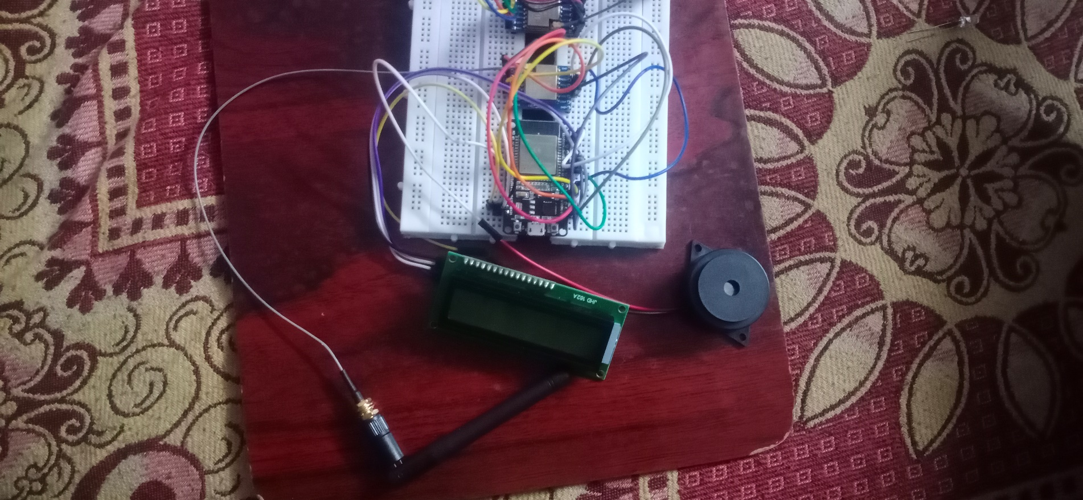

**Figure 10.1: Implemented Receiver with Gateway**

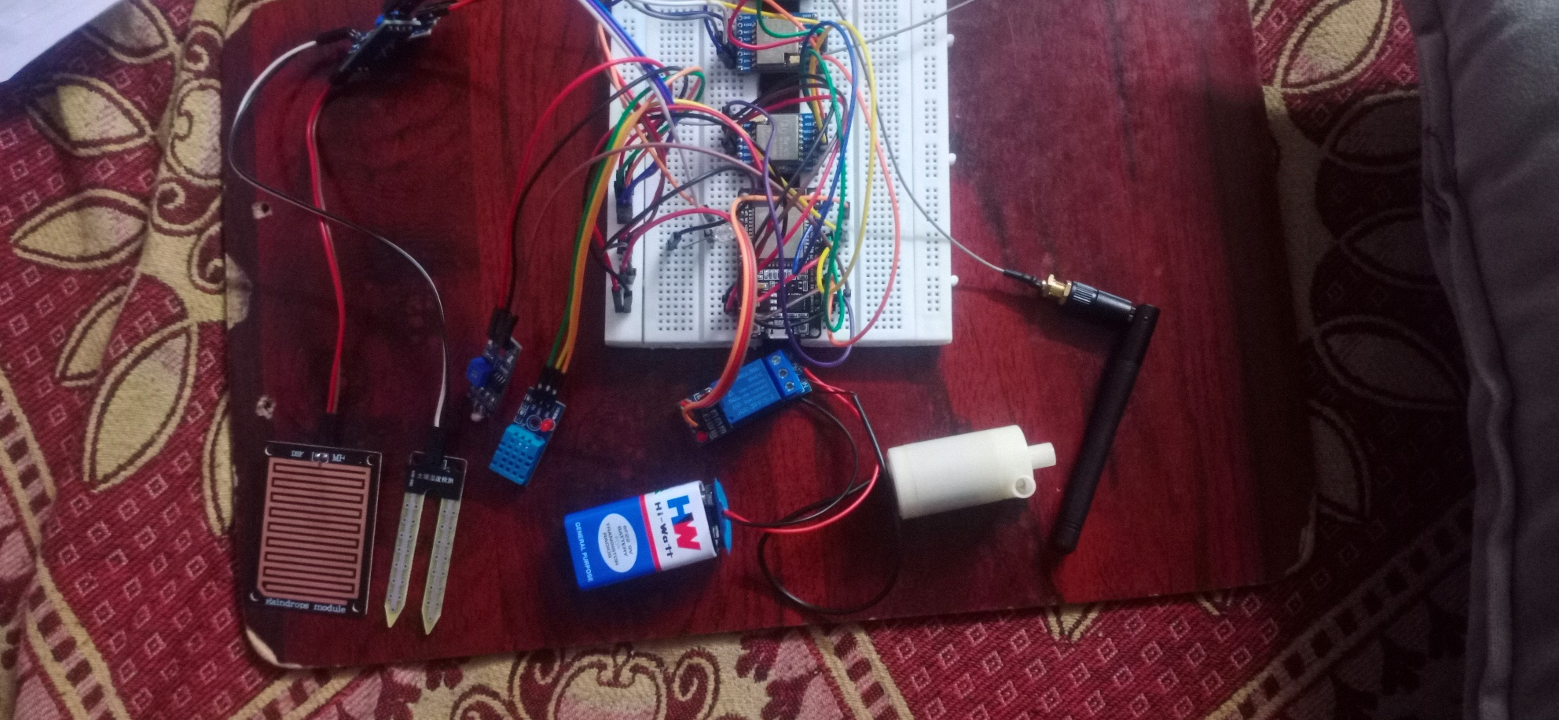

**Figure 10.2: Implemented Transmitter with Sensors**

**Figure**

**10.3:**

**Sensor Node TX RX With Serial Monitoring**

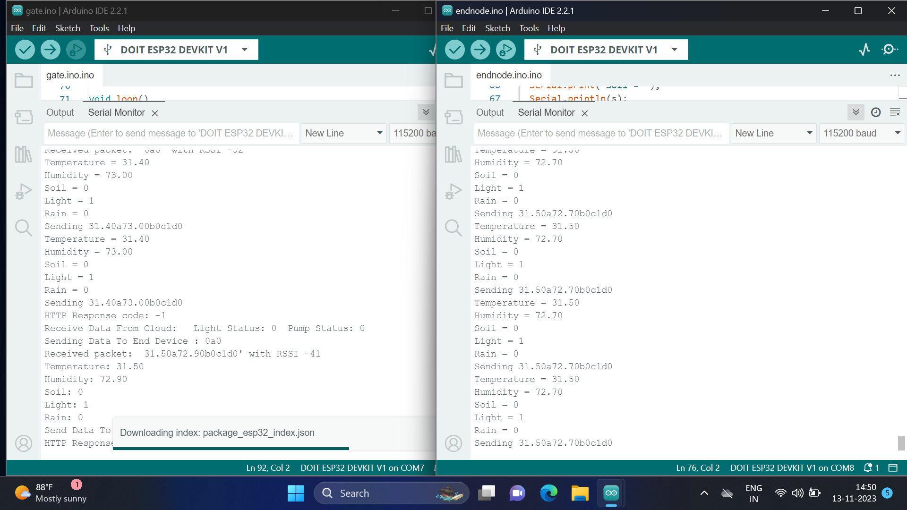

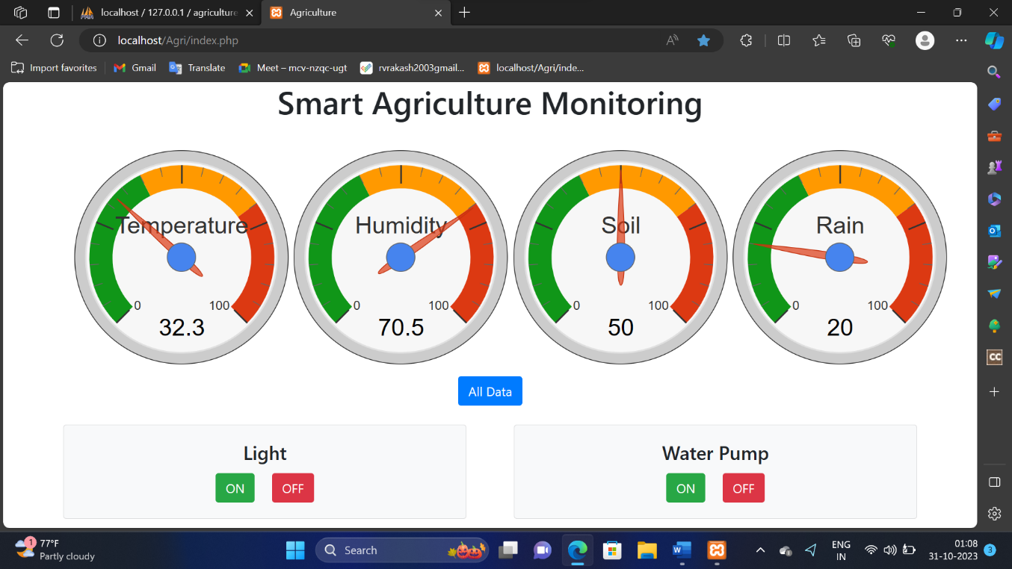We fetch the store data from the database and display it in various forms via the web site using PHP and HTML.

**Figure 10.4: Smart Agriculture Home Page of Web Site**

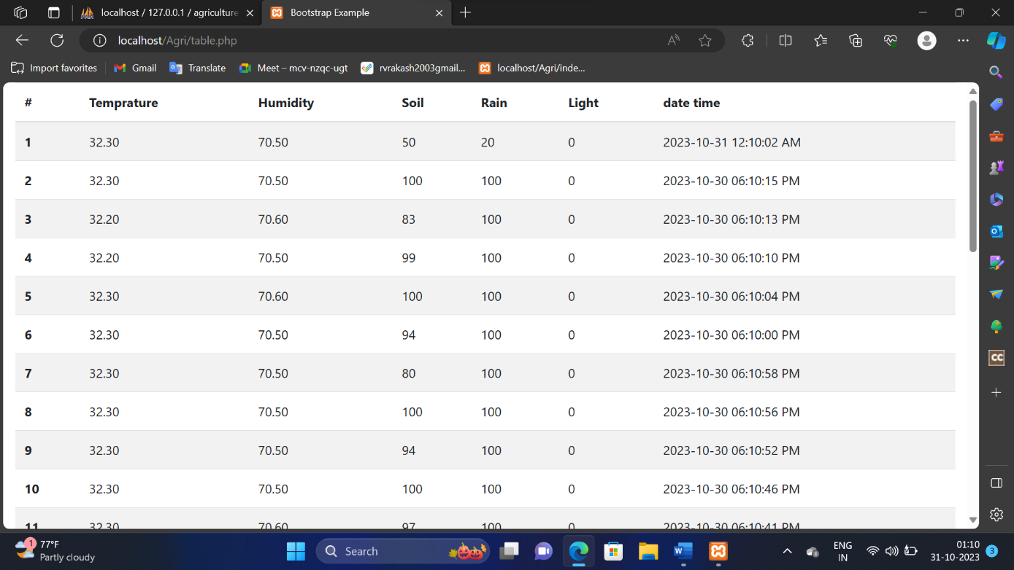We display the store data in tabular-form on the website.

**Figure 10.5: Collection of Live Sensor data in Table Form on Web Site**

# REFERENCES

1. Y. Kim, R. G. Evans, and W. M. Iversen, “Remote Sensing and Control of an Irrigation System Using a Distributed Wireless Sensor Network,” IEEE Trans. Instrum. Meas., vol. 57, no. 7, pp. 1379–1387, Jul. 2008, doi: 10.1109/TIM.2008.917198.
2. Hanggoro, M. A. Putra, R. Reynaldo, and R. F. Sari, “Green house monitoring and controlling using Android mobile application,” in 2013 International Conference on QiR, Jun. 2013, pp. 79–85, doi: 10.1109/QiR.2013.6632541.
3. Santoshkumar and Udaykumar R.Y, “Development of WSN system for precision agriculture,” in 2015 International Conference on Innovations in Information, Embedded and Communication Systems (ICIIECS), Mar. 2015, pp. 1–5, doi: 10.1109/ICIIECS.2015.7192904.
4. P. Gangurde and M. Bhende, “A Novel Approach for Precision Agriculture Using Wireless Sensor Network,” p. 8, 2015.
5. M. AshifuddinMondal and Z. Rehena, “IoT Based Intelligent Agriculture Field Monitoring System,” in 2018 8th International Conference on Cloud Computing, Data Science Engineering (Confluence), Jan. 2018, pp. 625–629, doi: 10.1109/CONFLUENCE.2018.8442535.
6. R. N. Rao and B. Sridhar, “IoT based smart crop-field monitoring and automation irrigation system,” in 2018 2nd International Conference on Inventive Systems and Control (ICISC), Jan. 2018, pp. 478–483, doi: 10.1109/ICISC.2018.8399118.
7. G. Sushanth and S. Sujatha, “IOT Based Smart Agriculture System,” in 2018 International Conference on Wireless Communications, Signal Processing and Networking (WiSPNET), Mar. 2018, pp. 1–4, doi: 10.1109/WiSPNET.2018.8538702.
8. M. Dholu and K. A. Ghodinde, “Internet of Things (IoT) for Precision Agriculture Application,” in 2018 2nd International Conference on Trends in Electronics and Informatics (ICOEI), May 2018, pp. 339–342, doi: 10.1109/ICOEI.2018.8553720.
9. D. I. Săcăleanu, R. Popescu, I. P. Manciu, and L. A. Perişoară, “Data Compression in Wireless Sensor Nodes with LoRa,” in 2018 10th International Conference on Electronics, Computers and Artificial Intelligence (ECAI), Jun. 2018, pp. 1–4, doi: 10.1109/ECAI.2018.8679003.
10. D. Davcev, K. Mitreski, S. Trajkovic, V. Nikolovski, and N. Koteli, “IoT agriculture system based on LoRaWAN,” in 2018 14th IEEE International Workshop on Factory Communication Systems (WFCS), Jun. 2018, pp. 1–4, doi: 10.1109/WFCS.2018.8402368.